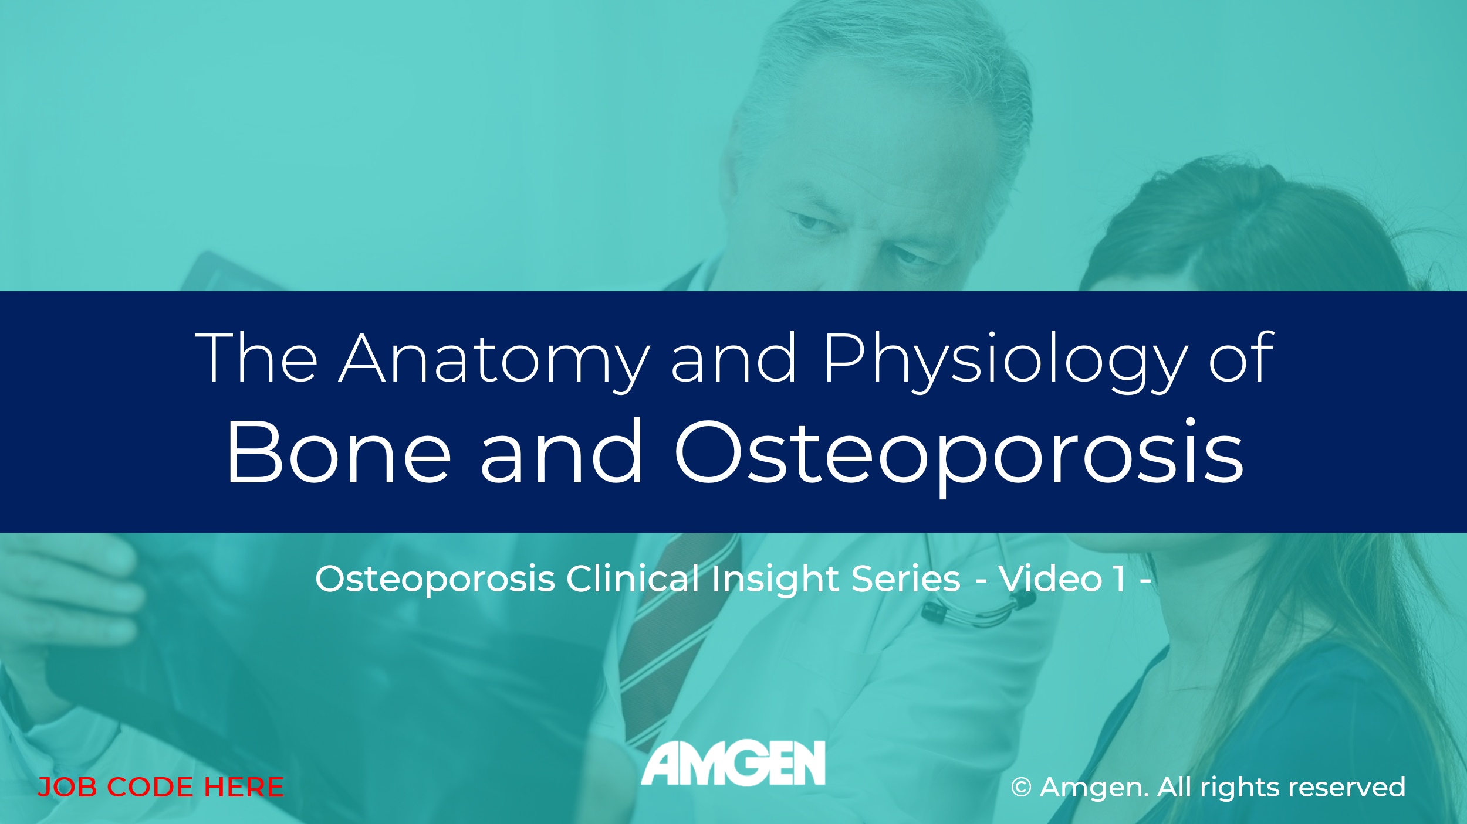

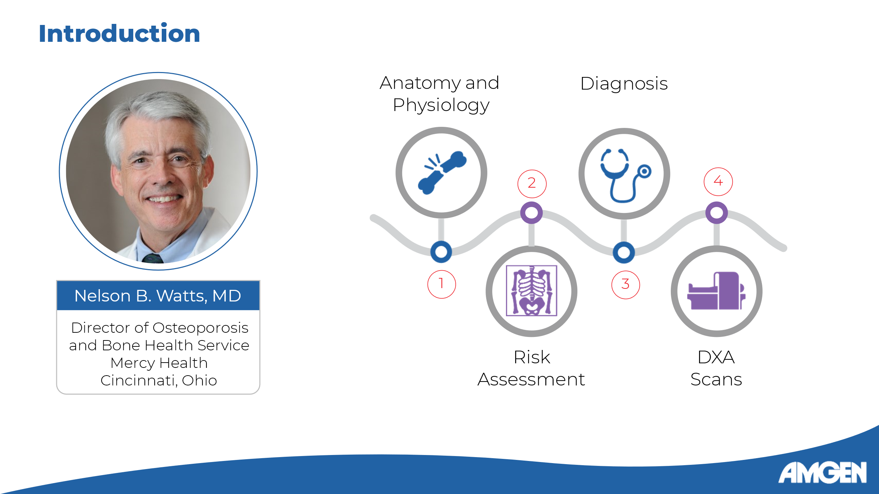
Slide 2:

[Dr. Watts] Hello, and welcome to the Osteoporosis Clinical Insight video series. I am Dr. Nelson Watts and I will be your guide in this series of four short videos exploring the anatomy and physiology, risk assessment, and diagnosis of osteoporosis, as well as the use of DXA imaging in bone quality assessment.

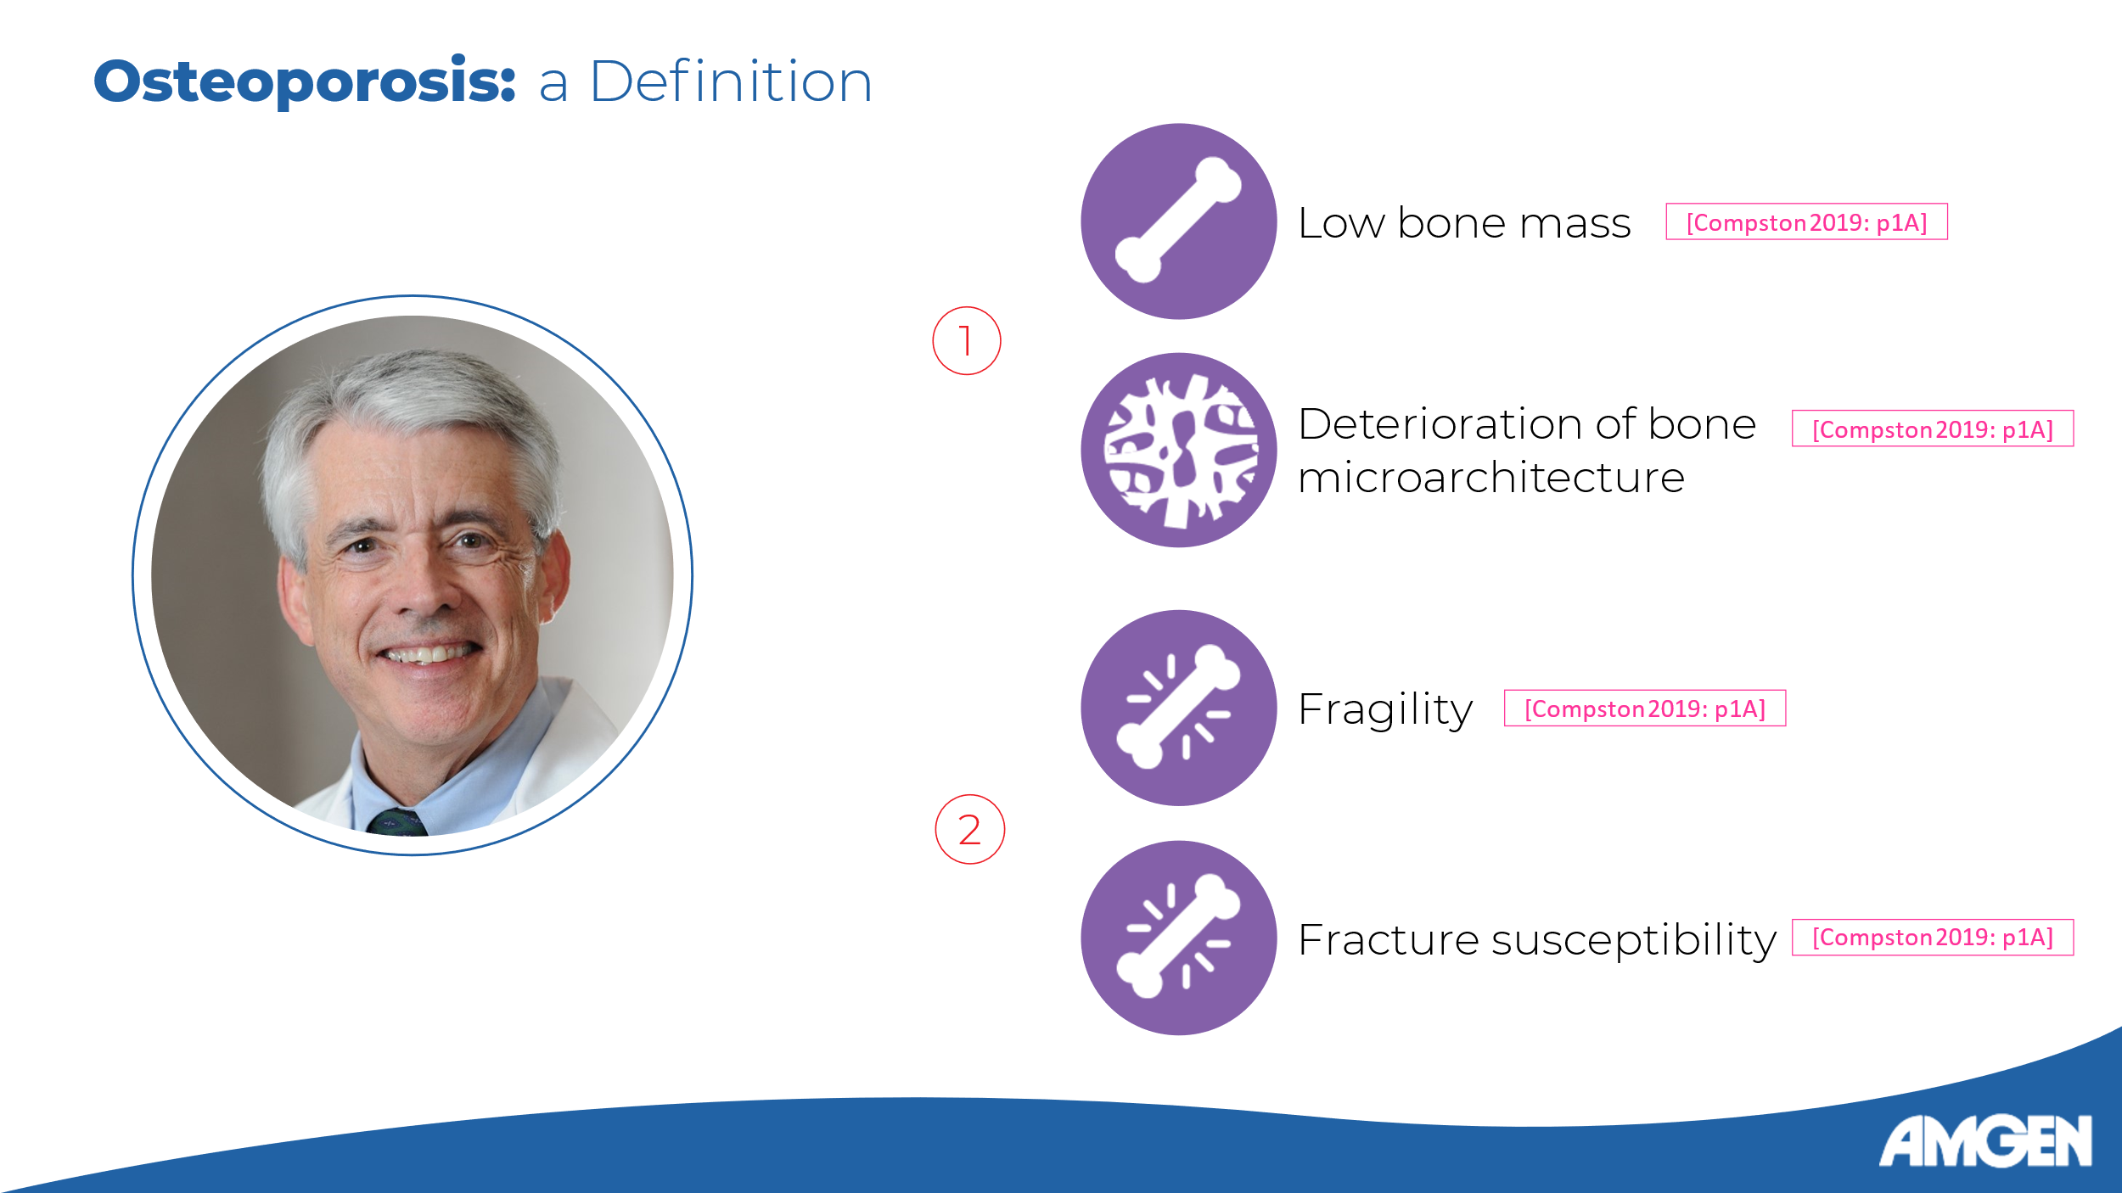
Slide 3:

[Dr. Watts] Osteoporosis is a systemic disease of the bone defined by two characteristic features: 1) low bone mass and deterioration of the bone microarchitecture, and 2) the resulting fragility and fracture susceptibility. [Compston 2019: p1A] In this first video, we will examine the normal architecture of the bone and the bone remodeling cycle, and discuss how changes to these structures and processes lead to osteoporosis.

Reference:
Compston JE, McClung MR, Leslie WD. Osteoporosis. Lancet. 2019 Jan 26;393(10169):364-376. [Compston 2019]

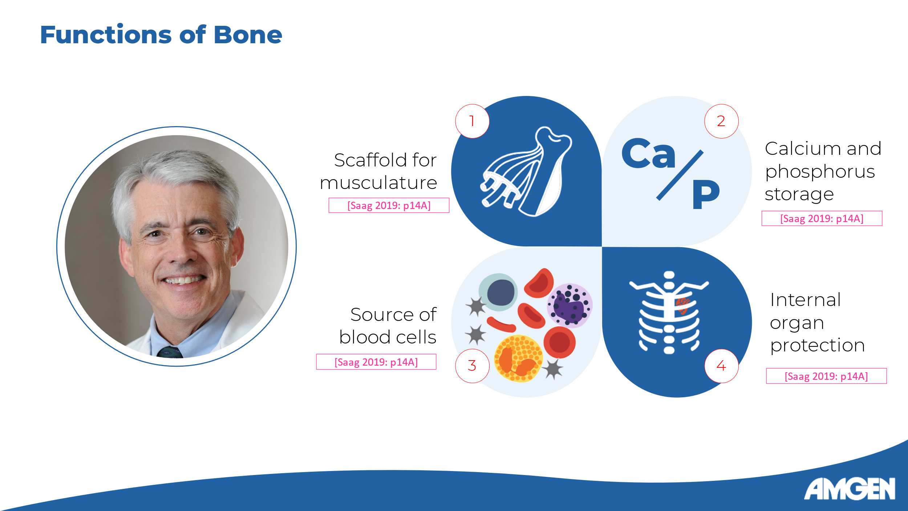
Slide 4:

[Dr. Watts] So, let’s begin. Bone is a dynamic tissue that is the primary constituent of the skeleton, serving as a scaffold for muscles, a calcium and phosphorus reservoir, the source of blood cells, and as protection for internal organs. [Saag 2019: p14A]

Reference:
Saag K, Morgan SL, Clines GA. Diagnosis and Management of Osteoporosis. 3rd ed. Professional Communications, Inc; 2019. [Saag 2019]

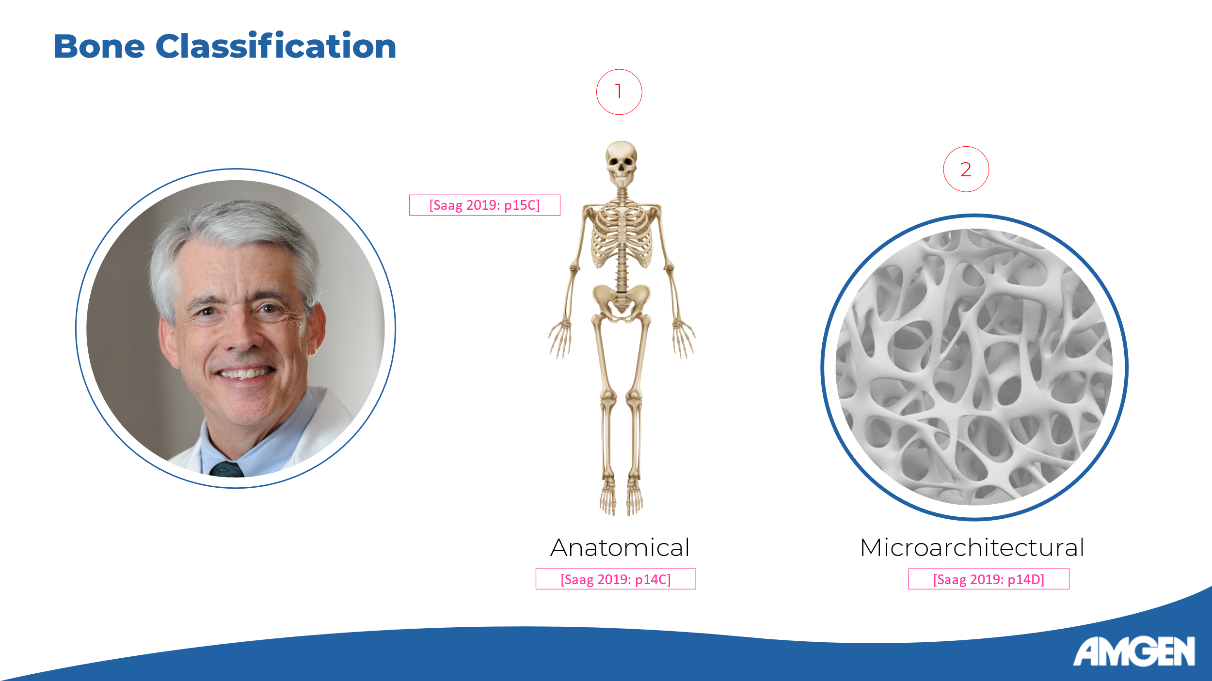
Slide 5:

[Dr. Watts] For the purpose of understanding osteoporosis, bone can be classified according to anatomy and microarchitecture. [Saag 2019: p14C-D]

Reference:
Saag K, Morgan SL, Clines GA. Diagnosis and Management of Osteoporosis. 3rd ed. Professional Communications, Inc; 2019. [Saag 2019]

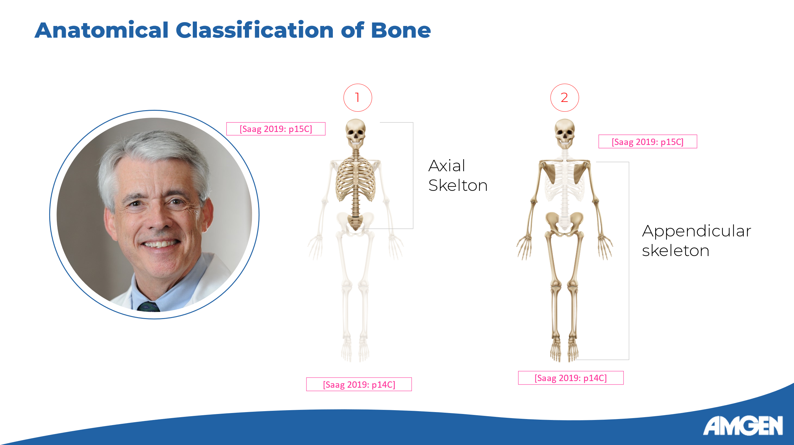
Slide 6:

[Dr. Watts] Anatomically, the skeleton is divided into the axial skeleton, which includes the skull, the spine, the sternum, the ribs, and the sacrum; and the appendicular skeleton, which comprises the clavicles, the scapulae, the pelvis, and the bones of the arms and legs. [Saag 2019: p14C]

Reference:
Saag K, Morgan SL, Clines GA. Diagnosis and Management of Osteoporosis. 3rd ed. Professional Communications, Inc; 2019. [Saag 2019]

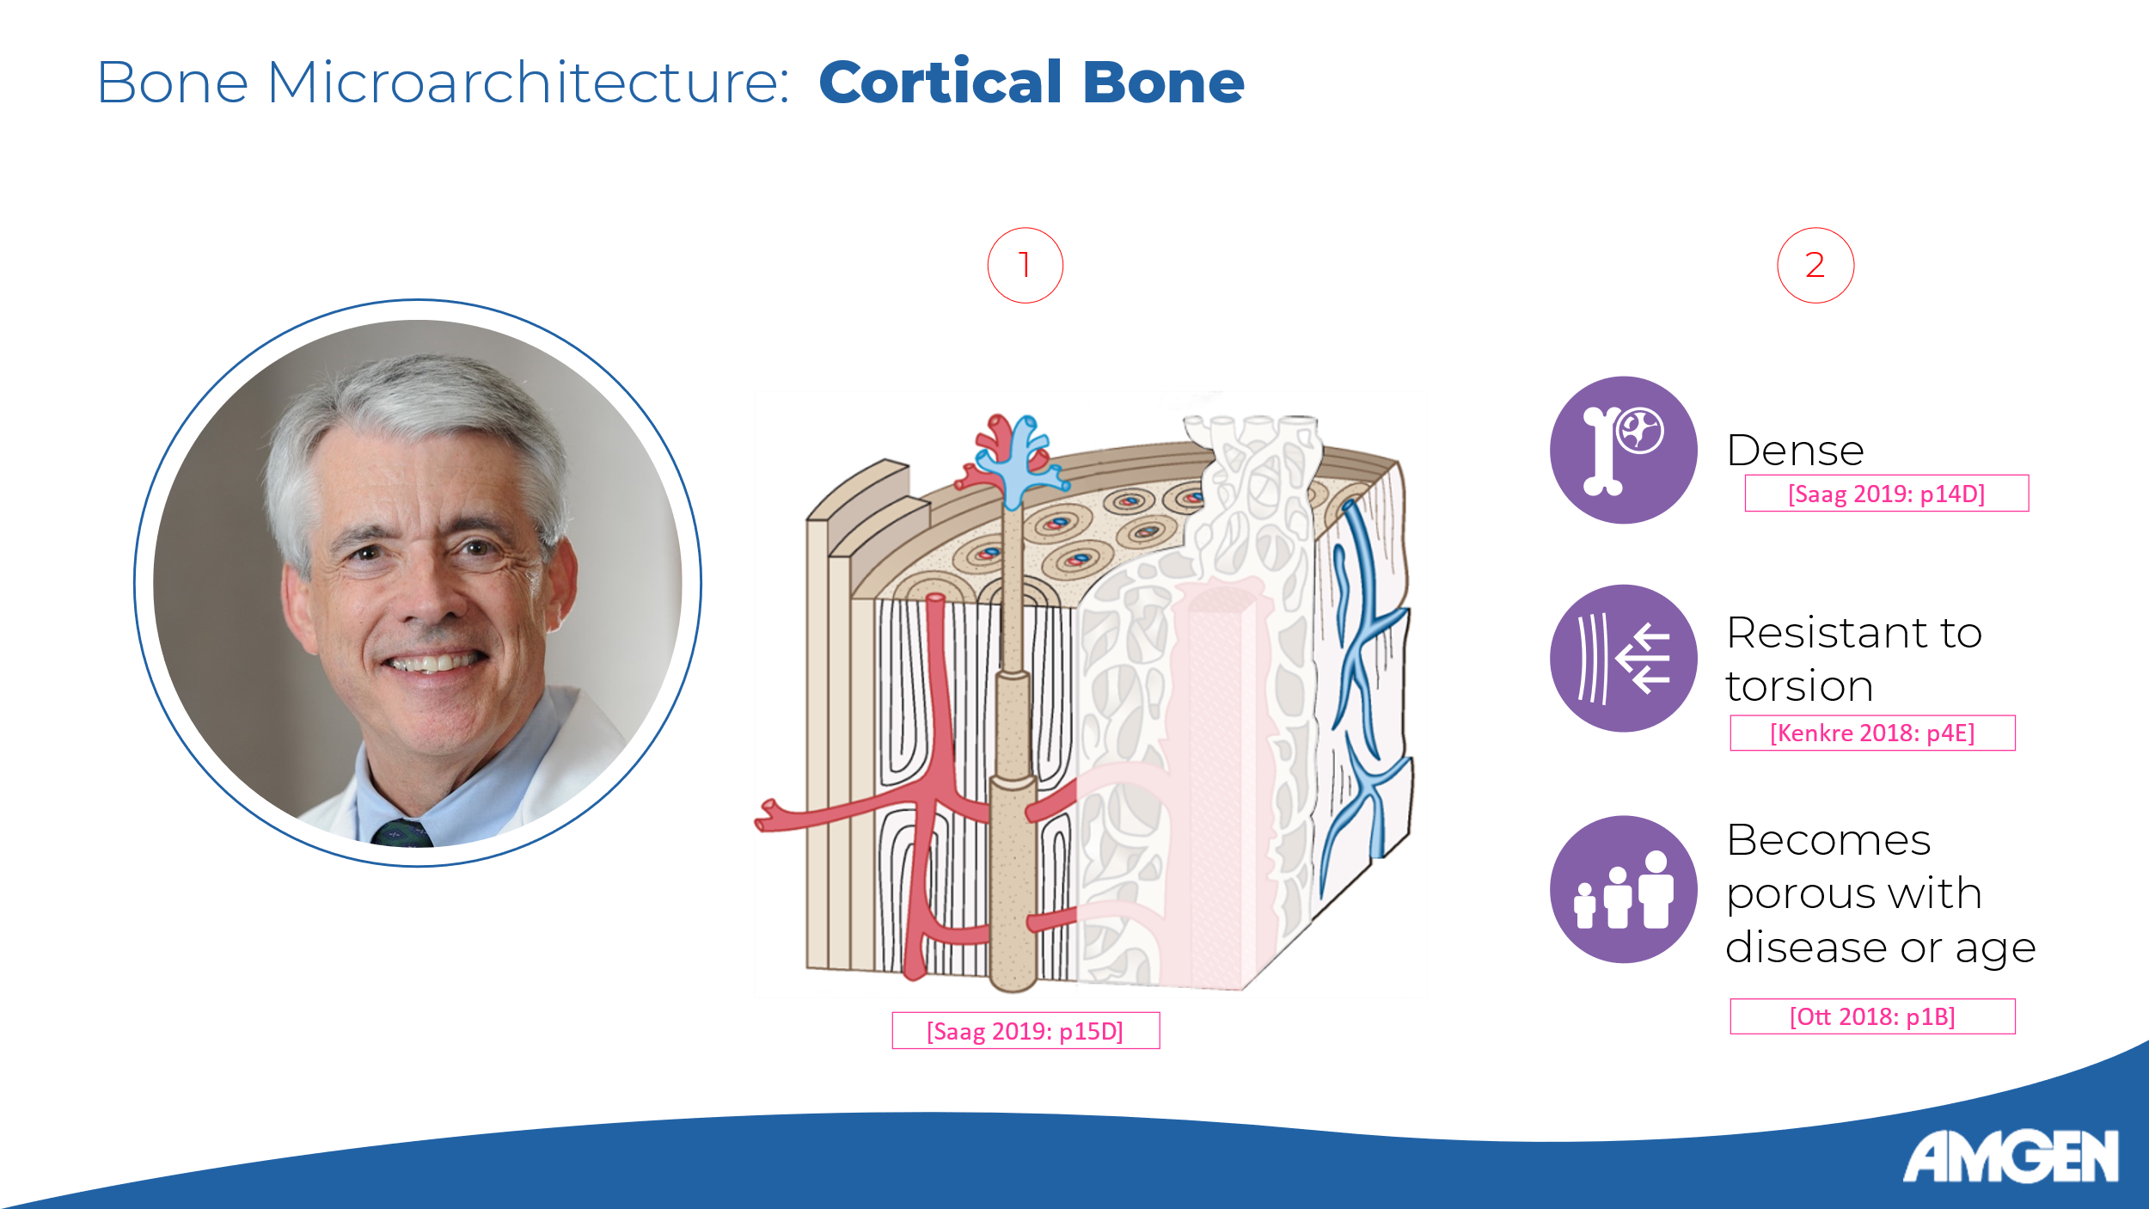
Slide 7:

[Dr. Watts] Microarchitecturally, bone tissue can be classified as cortical or trabecular. [Saag 2019: p14D] Cortical bone is the dense outer shell. It is solid but interspersed with vascular channels. [Ott 2018: p1B; Kenkre 2018: p4C, p4E] Cortical bone has high torsional resistance and provides support for torsional forces. [Saag 2019: p16I; Kenkre 2018: p4E] Cortical bone becomes more porous with age or disease, which leads to a loss of strength. [Ott 2018: p1B]

Slide 7 (alternative with snippet of “Introduction to Bone Biology” video):

[Dr. Watts] Microarchitecturally, bone tissue can be classified as cortical or trabecular. [Saag 2019: p14C-D] [Introduction to Bone Biology Video Segment 0:28-0:41 plays here] Cortical bone is solid but interspersed with vascular channels. [Ott 2018: p1B; Kenkre 2018: p4C, p4E] It has high torsional resistance and provides support for torsional forces. [Saag 2019: p16I; Kenkre 2018: p4E] Cortical bone becomes more porous with age or disease, which leads to a loss of strength. [Ott 2018: p1B]

References:
Saag K, Morgan SL, Clines GA. Diagnosis and Management of Osteoporosis. 3rd ed. Professional Communications, Inc; 2019. [Saag 2019]
Ott SM. Cortical or Trabecular Bone: What's the Difference? Am J Nephrol. 2018;47(6):373-375. [Ott 2018]
Kenkre JS, Bassett J. The bone remodelling cycle. Ann Clin Biochem. 2018 May;55(3):308-327. [Kenkre 2018]

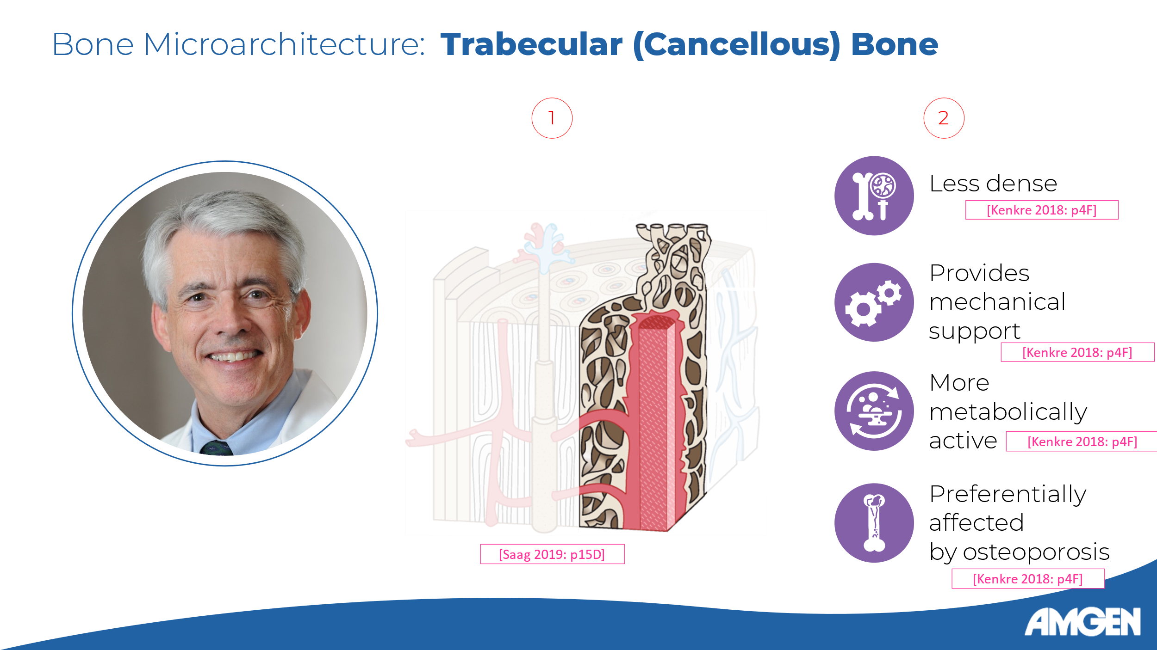
Slide 8:

[Dr. Watts] Trabecular bone - also called cancellous or spongy bone - is the inner, less dense and more elastic part of the bone, which provides compression resistance. [Kenkre 2018: p4F] It is composed of a honeycomb-like lattice of bone tissue, and accounts for approximately 20% of total bone mass. [Ott 2018: p1B-C; Saag 2019: p15B, p16A] The rods and plates that make up the trabecular bone lattice are arranged in patterns that provide maximal strength and mechanical support to the bone. [Kenkre 2018: p4F] Owing to its larger surface area, trabecular bone is more metabolically active and has a higher turnover rate than cortical bone, and is preferentially affected by osteoporosis. [Kenkre 2018: p4F]

Slide 8 (alternative with snippet of “Introduction to Bone Biology” video):

[Dr. Watts] Trabecular bone - also called cancellous or spongy bone - is the inner, less dense and more elastic part of the bone. [Kenkre 2018: p4F] [Introduction to Bone Biology Video Segment 1:35-1:43 plays here] It is composed of a honeycomb-like lattice of bone tissue, and accounts for approximately 20% of total bone mass. [Ott 2018: p1B-C; Saag 2019: p15B, p16A] The rods and plates that make up the trabecular bone lattice are arranged in patterns that provide maximal strength and mechanical support to the bone. [Kenkre 2018: p4F] Owing to its larger surface area, trabecular bone is more metabolically active and has a higher turnover rate than cortical bone, and is preferentially affected by osteoporosis. [Kenkre 2018: p4F]

References:
Kenkre JS, Bassett J. The bone remodelling cycle. Ann Clin Biochem. 2018 May;55(3):308-327. [Kenkre 2018]
Ott SM. Cortical or Trabecular Bone: What's the Difference? Am J Nephrol. 2018;47(6):373-375. [Ott 2018]
Saag K, Morgan SL, Clines GA. Diagnosis and Management of Osteoporosis. 3rd ed. Professional Communications, Inc; 2019. [Saag 2019]

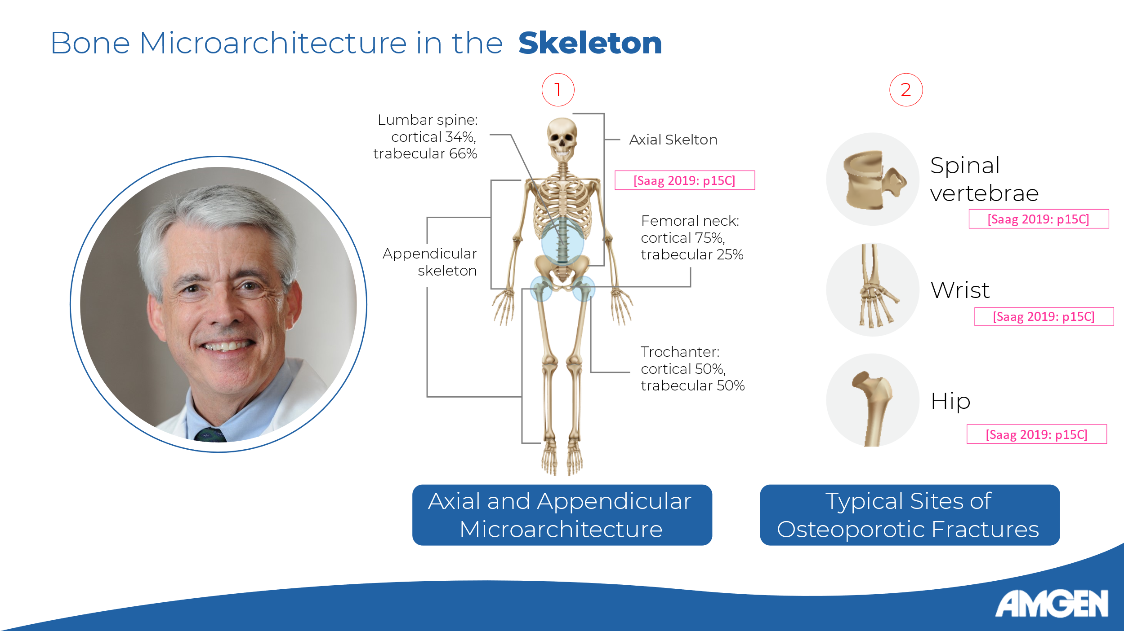
Slide 9:

[Dr. Watts] Every bone in the skeleton contains both cortical and trabecular parts, although the proportion varies for each bone, and depends on the individual bone’s function. [Ott 2018: p1A; Saag 2019: p15C] Cortical bone predominates in the appendicular skeleton as its bones need to resist both torsional and compressive forces. Conversely, trabecular bone predominates in the axial skeleton, particularly the vertebral column, which is subjected mostly to compressive forces. [Kenkre 2018: p4G; Saag 2019: p16B] Compressive fractures of the spinal vertebrae are classic osteoporotic fractures. Other common fracture sites include the wrist and the hip, but osteoporotic fractures can occur in other bones as well. [Ott 2018: p1F; Saag 2019: p15C]

References:
Ott SM. Cortical or Trabecular Bone: What's the Difference? Am J Nephrol. 2018;47(6):373-375. [Ott 2018]
Saag K, Morgan SL, Clines GA. Diagnosis and Management of Osteoporosis. 3rd ed. Professional Communications, Inc; 2019. [Saag 2019]
Kenkre JS, Bassett J. The bone remodelling cycle. Ann Clin Biochem. 2018 May;55(3):308-327. [Kenkre 2018]

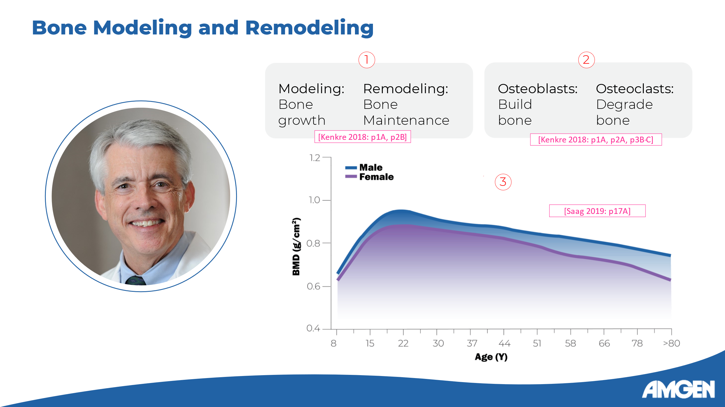
Slide 10:

[Dr. Watts] Now that we have a better understanding of bone structure, let’s discuss how bone is built and maintained during a person’s lifespan. We call these processes bone modelling and bone remodelling, respectively. [Kenkre 2018: p1A] Both processes involve bone formation, carried out by cells called osteoblasts, and bone resorption (or degradation), carried out by cells called osteoclasts. [Kenkre 2018: p2A, p3B-C] These processes are developmentally regulated; during bone modeling in childhood and adolescence, more bone formation than bone resorption occurs. Peak bone mass is achieved by age 30 in both men and women. [Saag 2019: p16H, p16J, p17C-D] In adulthood, there is a delicate balance between formation and resorption in the bone remodeling cycle. [Kenkre 2018: p2B] However, as shown in this graph, later in life the balance shifts towards resorption, leading to age-related bone density loss. In women, this is further exacerbated by menopause, which tips the balance even more toward resorption. [Saag 2019: p17A, p17D]

References:
Kenkre JS, Bassett J. The bone remodelling cycle. Ann Clin Biochem. 2018 May;55(3):308-327. [Kenkre 2018]
Saag K, Morgan SL, Clines GA. Diagnosis and Management of Osteoporosis. 3rd ed. Professional Communications, Inc; 2019. [Saag 2019]

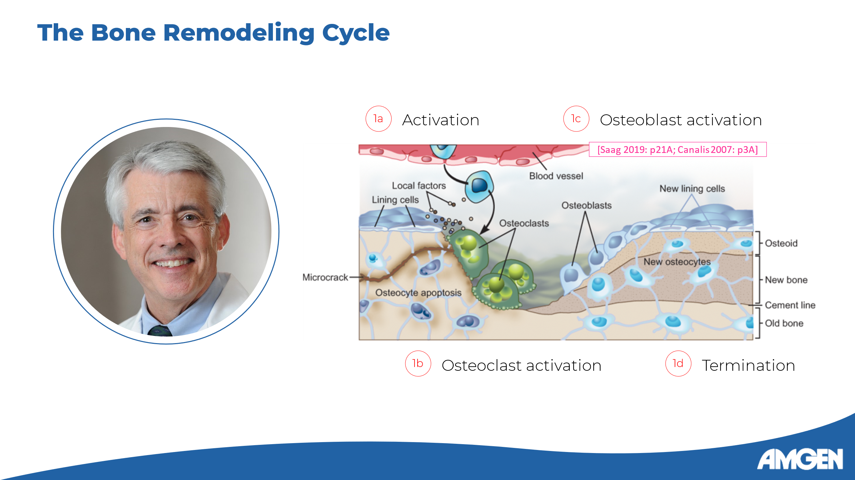
Slide 11:

[Dr. Watts] At the cellular level, the bone remodeling cycle occurs in several distinct steps. [Saag 2019: p21A] In targeted remodelling, which refers to the replacement of a specific area of old or damaged bone, the activation signal originates from osteocytes, cells embedded in the bone matrix. [Saag 2019: p21D] Osteocytes undergo apoptosis, or programmed cell death, releasing factors that induce stromal cells to differentiate into osteoclasts, which resorb the old or damaged bone matrix. [Saag 2019: p22B] It is important to mention that bone remodeling can also initiate in response to systemic hormonal changes that regulate mineral homeostasis. [Kenkre 2018: p6B, p7C] Either way, after the resorption phase ends, osteoclasts undergo apoptosis, clearing the way for osteoblasts, whose differentiation and activation is mediated by other intercellular signals. Osteoblasts secrete the new bone matrix and promote its mineralization together with osteocytes. [Saag 2019: p22C] Finally, in the termination stage, remaining osteoblasts differentiate into bone lining cells and new osteocytes. [Saag 2019: p22D]

References:
Saag K, Morgan SL, Clines GA. Diagnosis and Management of Osteoporosis. 3rd ed. Professional Communications, Inc; 2019. [Saag 2019]

Kenkre JS, Bassett J. The bone remodelling cycle. Ann Clin Biochem. 2018 May;55(3):308-327. [Kenkre 2018]
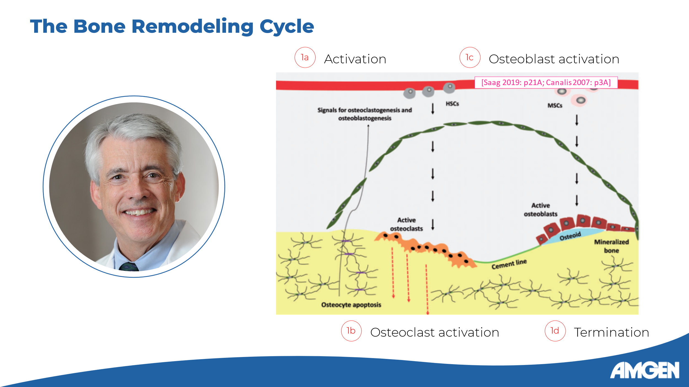
Slide 11 (with alternative image):

[Dr. Watts] At the cellular level, the bone remodeling cycle occurs in several distinct steps. [Saag 2019: p21A] In targeted remodelling, which refers to the replacement of a specific area of old or damaged bone, the activation signal originates from osteocytes, cells embedded in the bone matrix. [Saag 2019: p21D] Osteocytes undergo apoptosis, or programmed cell death, releasing factors that induce stromal cells to differentiate into osteoclasts, which resorb the old or damaged bone matrix. [Saag 2019: p22B] It is important to mention that bone remodeling can also initiate in response to systemic hormonal changes that regulate mineral homeostasis. [Kenkre 2018: p6B, p7C] Either way, after the resorption phase ends, osteoclasts undergo apoptosis, clearing the way for osteoblasts, whose differentiation and activation is mediated by other intercellular signals. Osteoblasts secrete the new bone matrix and promote its mineralization together with osteocytes. [Saag 2019: p22C] Finally, in the termination stage, remaining osteoblasts differentiate into bone lining cells and new osteocytes. [Saag 2019: p22D]

References:
Saag K, Morgan SL, Clines GA. Diagnosis and Management of Osteoporosis. 3rd ed. Professional Communications, Inc; 2019. [Saag 2019]
Kenkre JS, Bassett J. The bone remodelling cycle. Ann Clin Biochem. 2018 May;55(3):308-327. [Kenkre 2018]

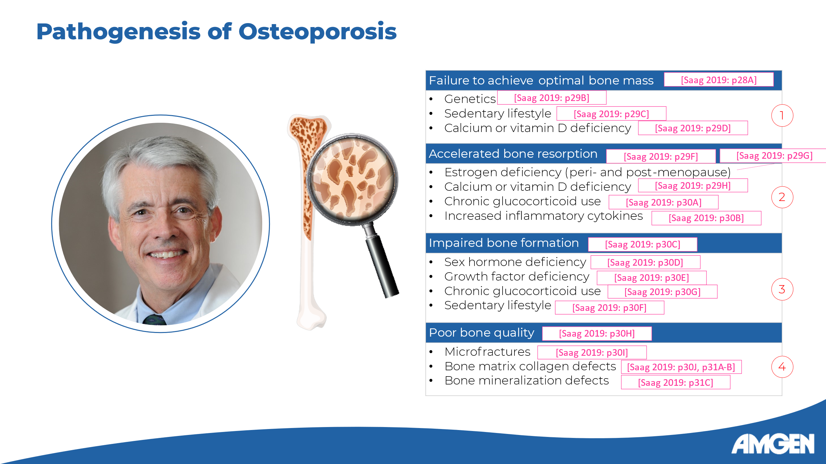
Slide 12:
[Dr. Watts] Now that we have reviewed the normal physiology of bone, we can understand the pathogenesis of osteoporosis. It typically results from one or more of the following four processes:
1) Failure to achieve an optimal bone mass before the age of 30, due to genetic factors, a sedentary lifestyle, or a calcium or vitamin D deficiency. [Saag 2019: p28A, p29A]
2) Accelerated bone resorption, resulting in net bone loss. This can result from an estrogen deficiency in peri- and postmenopausal women, calcium or vitamin D deficiency, long-term glucocorticoid use, and increased inflammatory cytokine activity. [Saag 2019: p29F-H, p30A-B]
3) Impaired bone formation, which also results in net bone loss, and can occur because of sex hormone deficiency, growth factor deficiency, chronic glucocorticoid treatment, and even a sedentary lifestyle; [Saag 2019: p30C-G] and finally:
4) Poor bone quality, including the presence of microfractures (which can initiate larger fractures), the arrangement and the amount of crosslinking of bone matrix collagen, as well as the ratio of mineral to matrix in the bone. [Saag 2019: p30H-J, p31A-C]

Reference:
Saag K, Morgan SL, Clines GA. Diagnosis and Management of Osteoporosis. 3rd ed. Professional Communications, Inc; 2019. [Saag 2019]

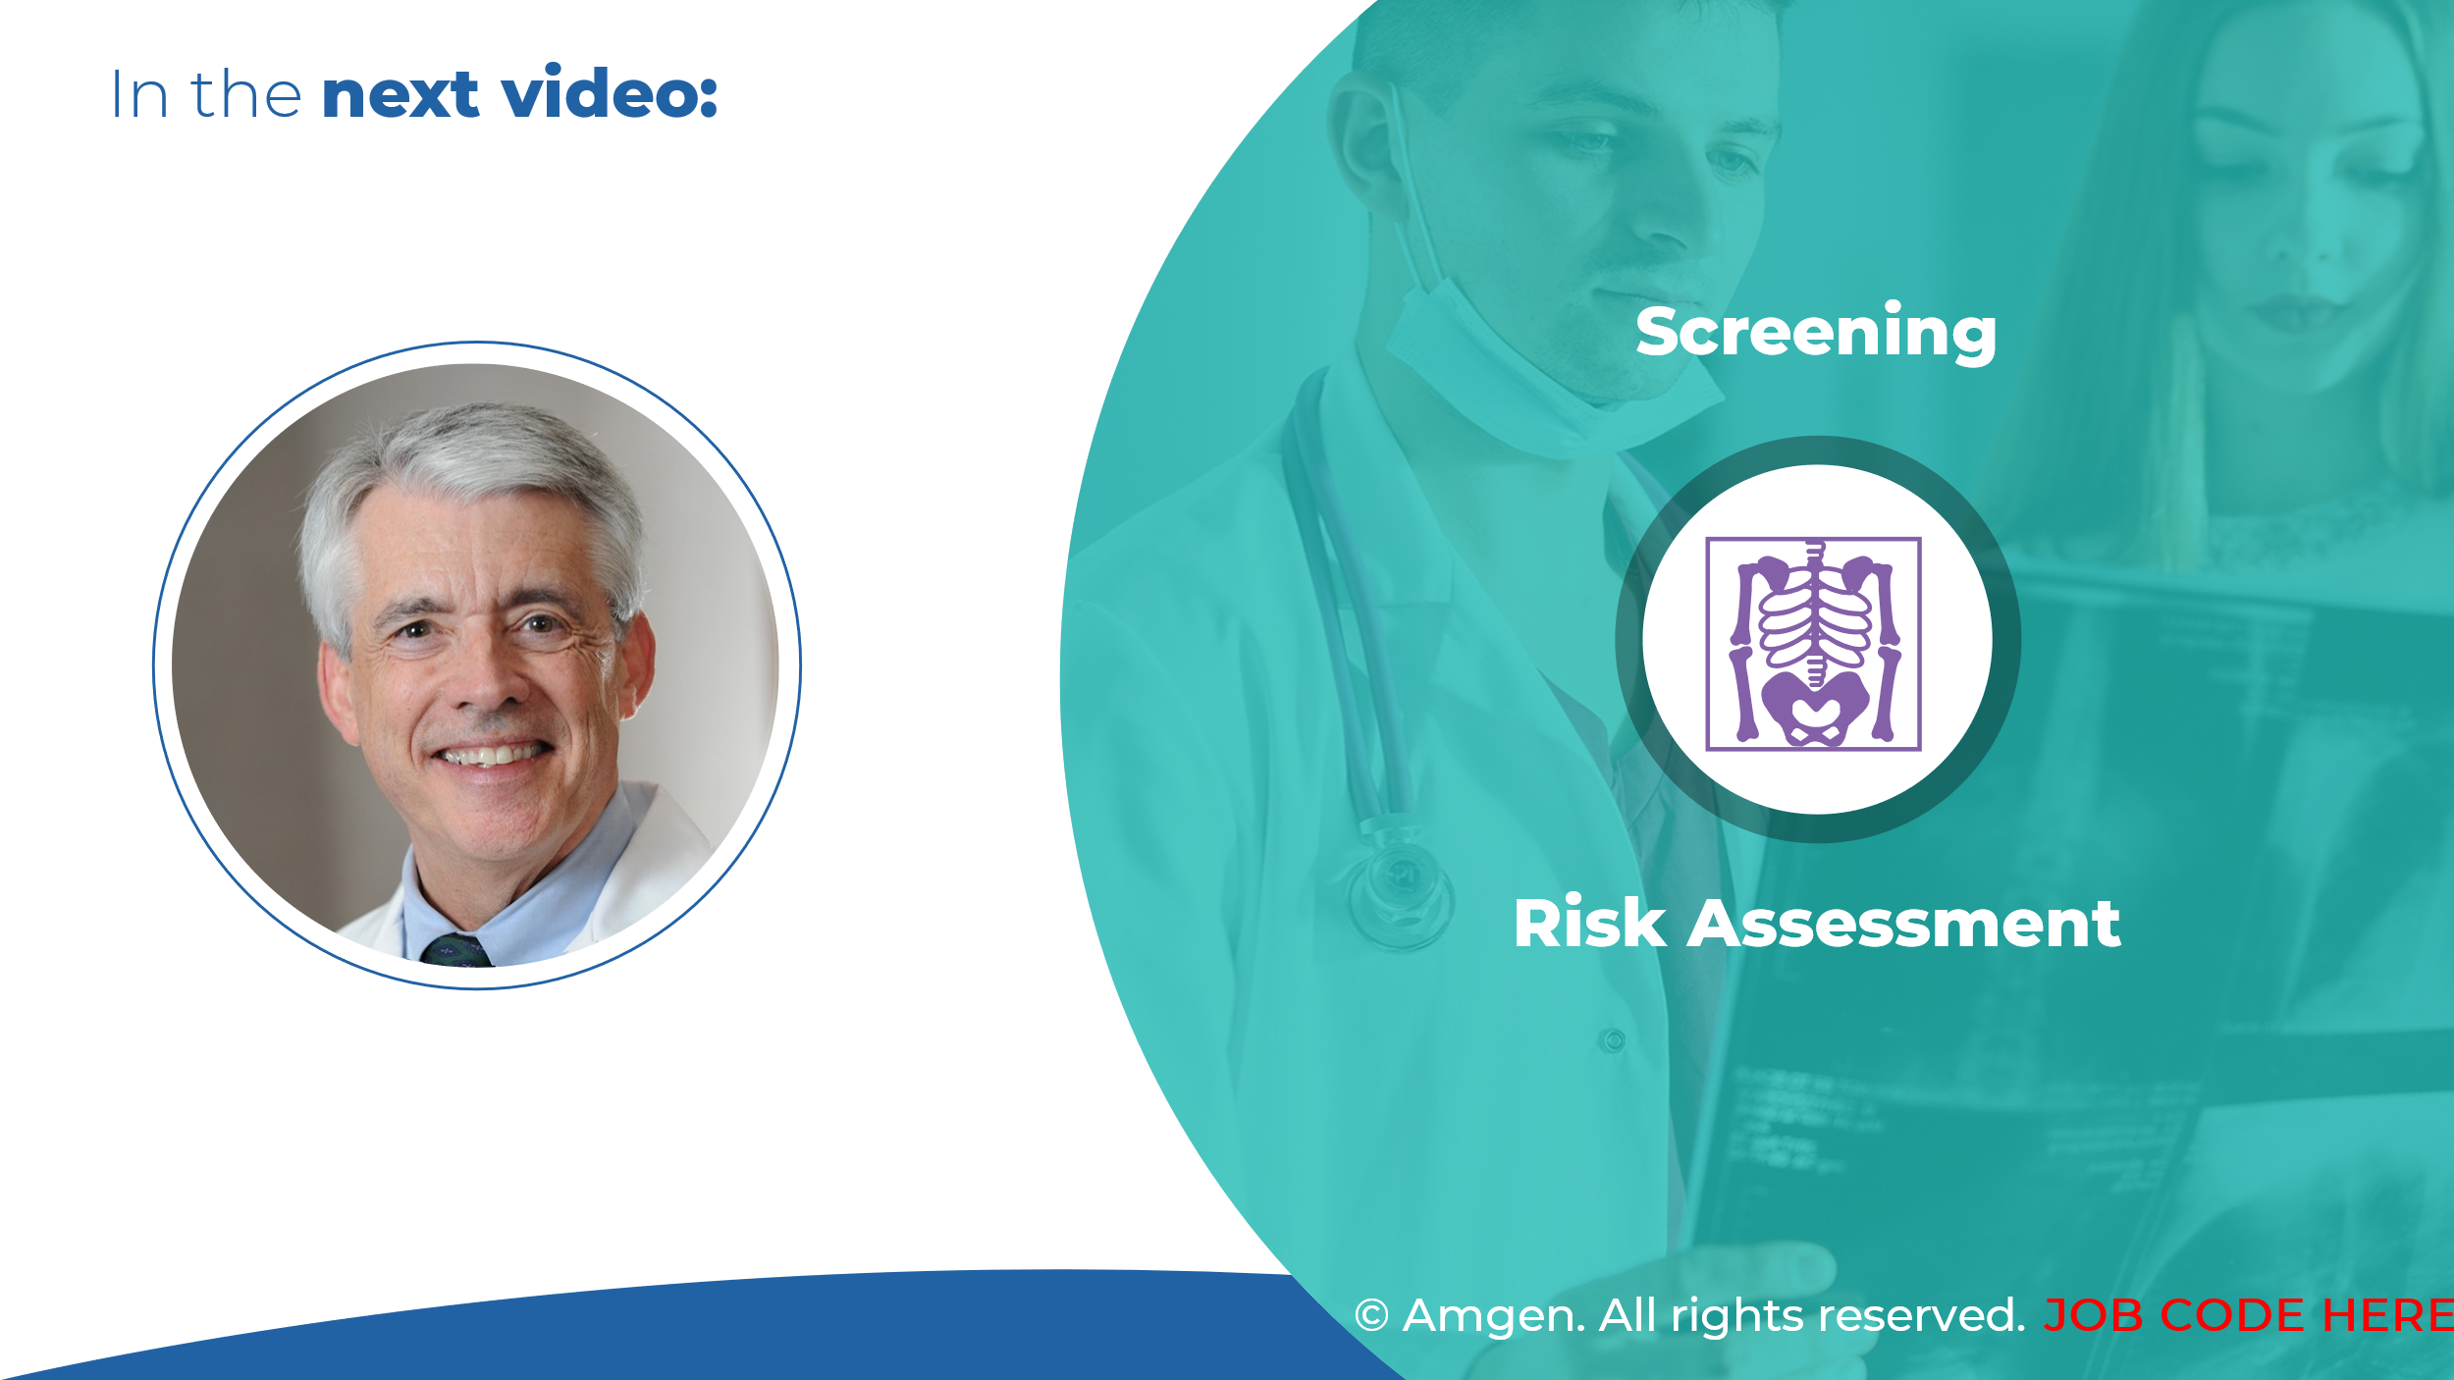
Slide 13:
[Dr. Watts] This concludes the first video in the Osteoporosis Clinical Insight series. Next time, we will take a look at osteoporosis screening and fracture risk assessment.

