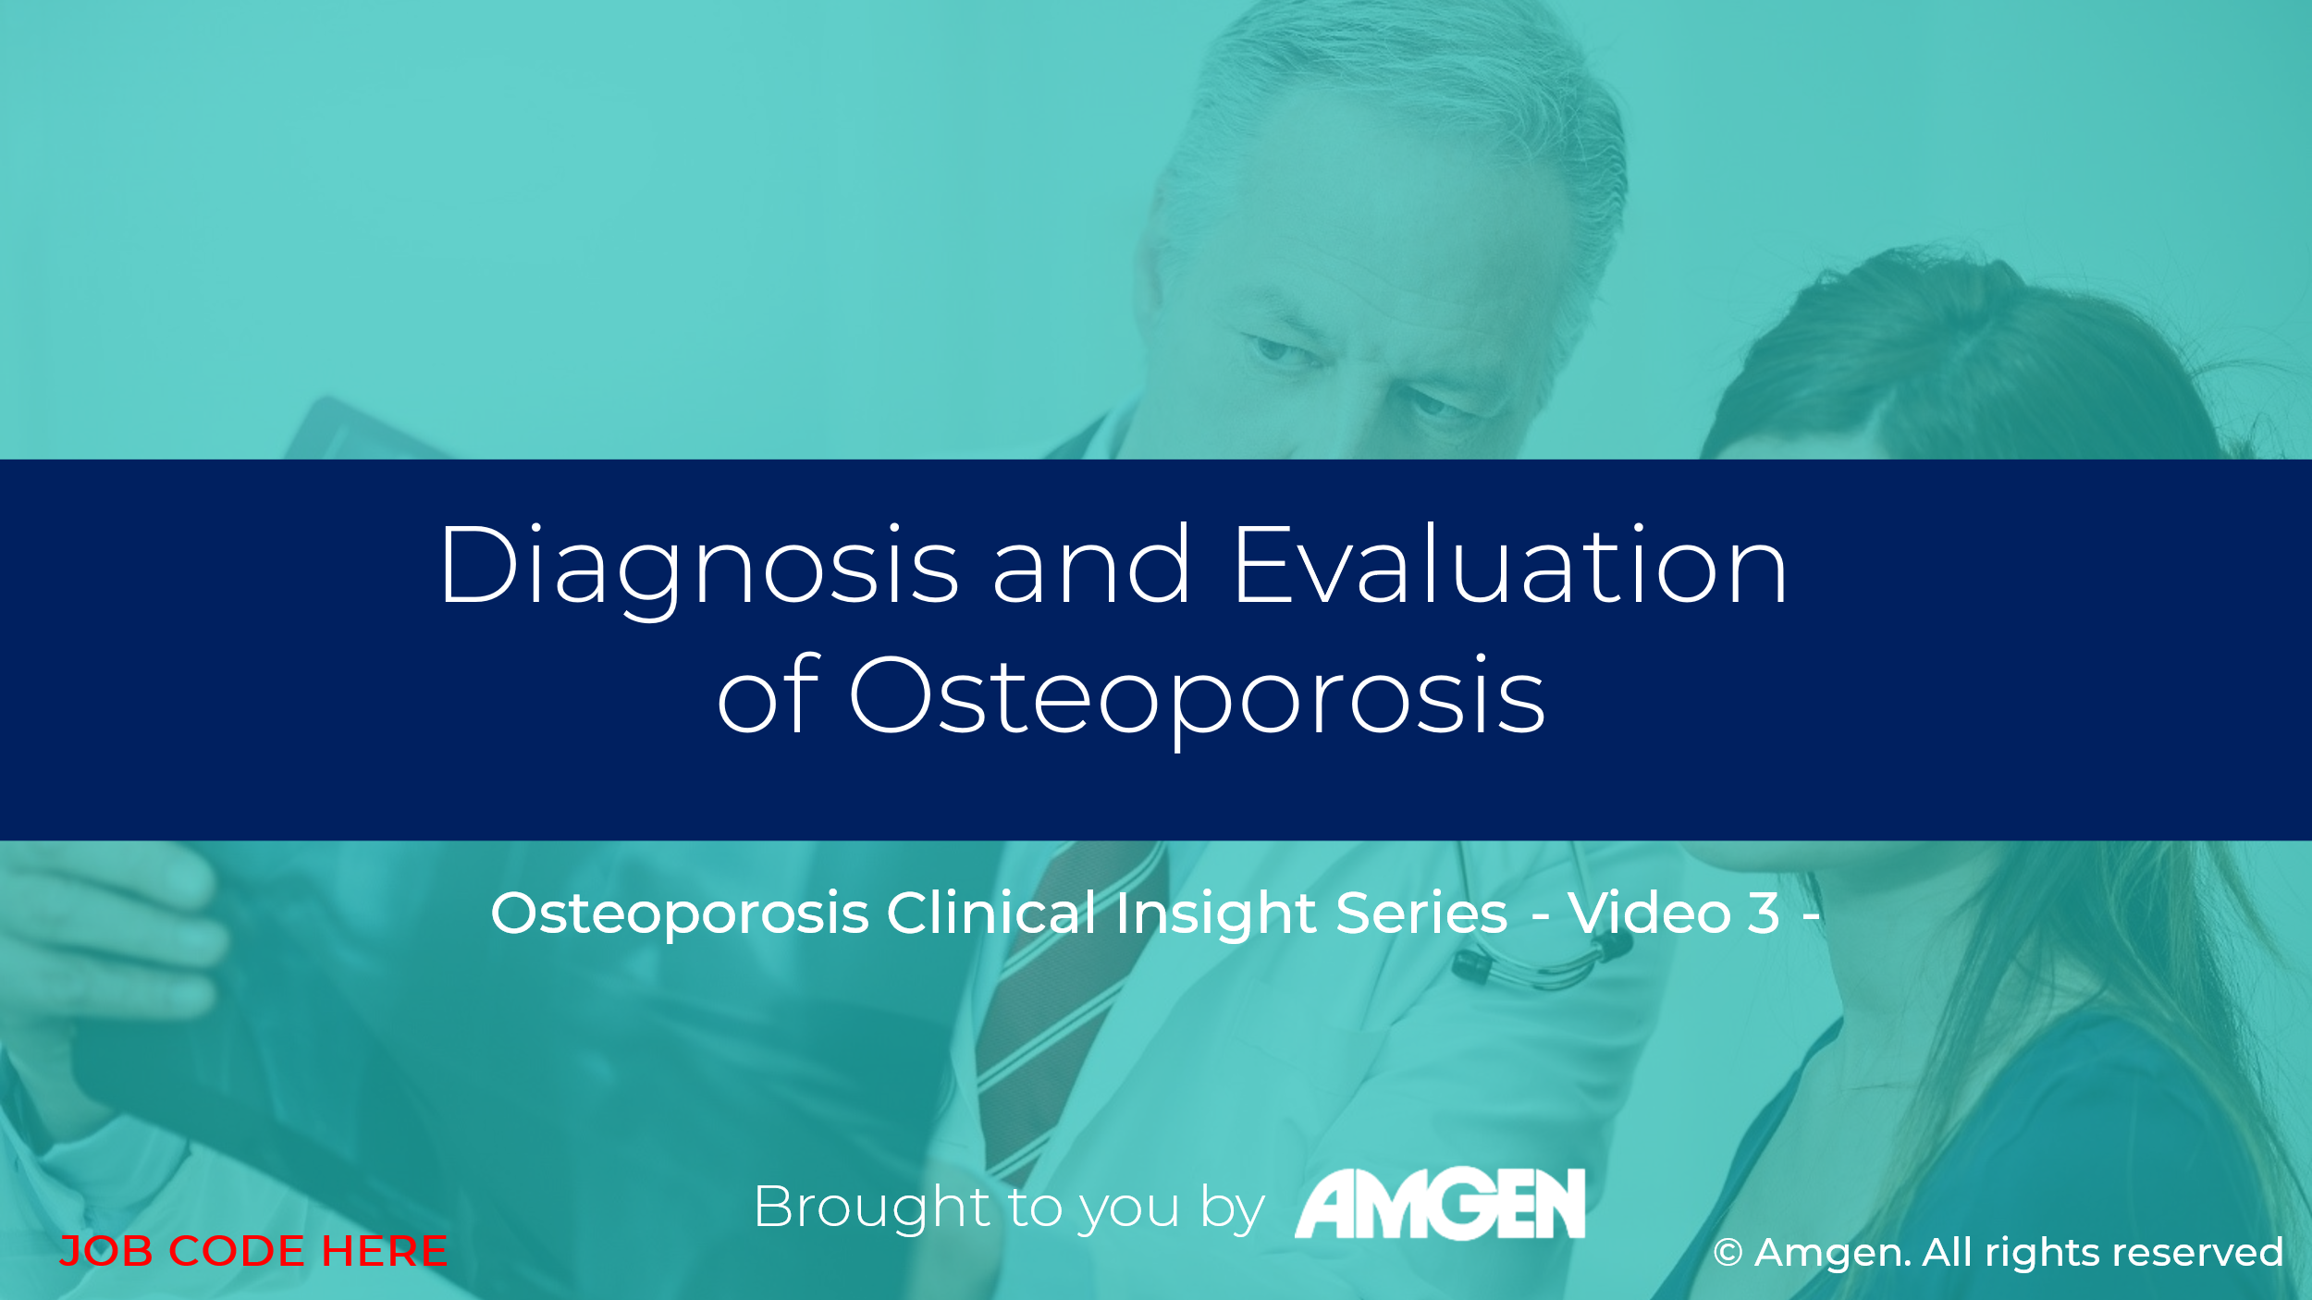

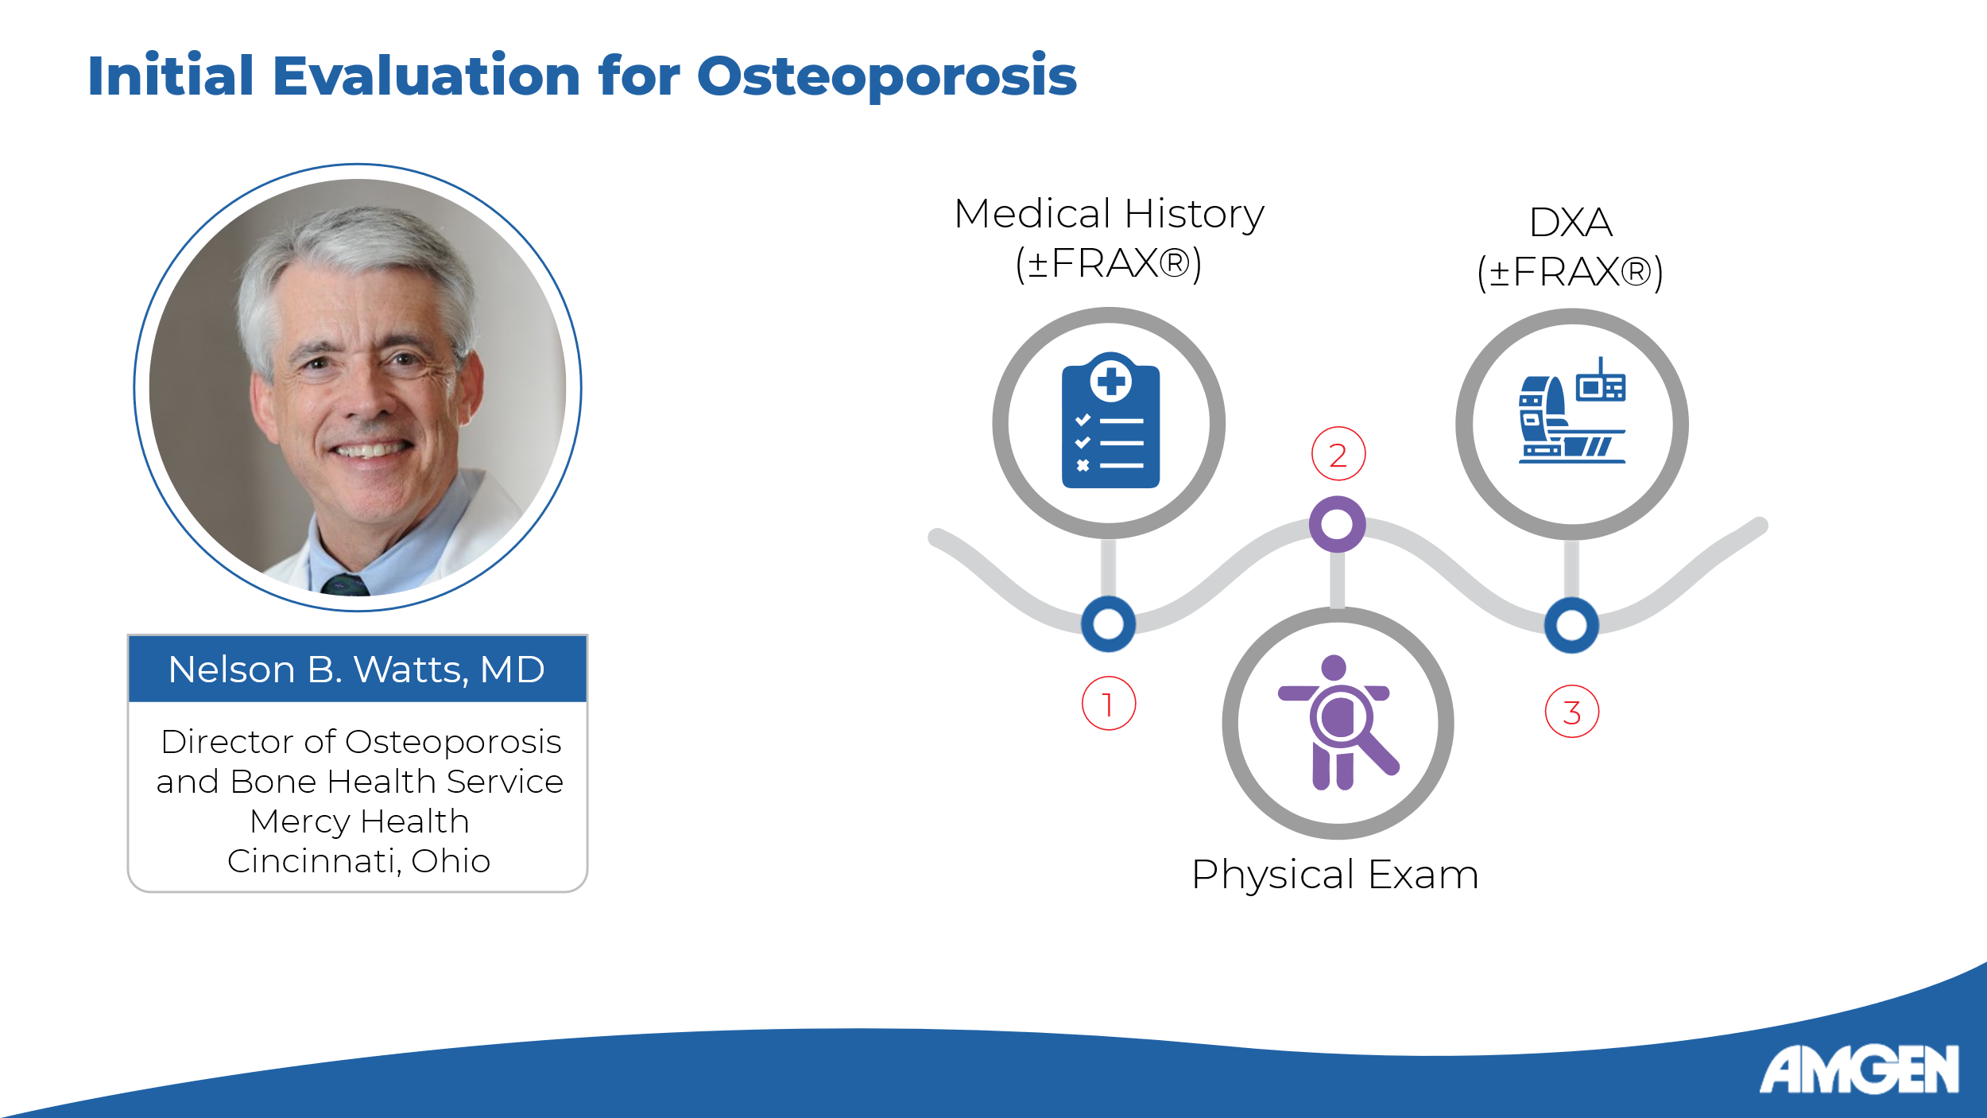
Slide 2 (Integrated US-Global Version):
[Dr. Watts] Hello, and welcome to the third video in the Osteoporosis Clinical Insight series. I am Dr. Nelson Watts, and I will be your guide as we discuss how osteoporosis is diagnosed, and how it is evaluated following diagnosis.
[Dr. Watts] The initial evaluation for osteoporosis comprises three elements. First, a detailed medical history is taken, which may reveal risk factors such as those we discussed in the last video, including a family history of osteoporosis and previous fracture. At this stage, FRAX or another clinical risk assessment tool may be used, which is typical for countries outside the United States. [Camacho 2020: p3B; Saag: p36B-C] Second, a general physical and musculoskeletal examination is performed. This may reveal important clinical signs, including kyphosis, scoliosis, appropriate lumbar lordosis, height loss, leg length disparity, and pelvic tilt or rotation,, all of which point to increased fracture risk and possible prior fractures. [Camacho 2020: p3B; Saag: p36B-C, p43C-D] Finally, the patient’s clinical fracture risk profile informs whether BMD should be measured, for which DXA is typically employed. In the United States, FRAX risk assessment is typically performed at this stage rather than earlier, as DXA scanners usually come with integrated FRAX software. [Camacho 2020: p3C-D; Watts: 2011: p3A]

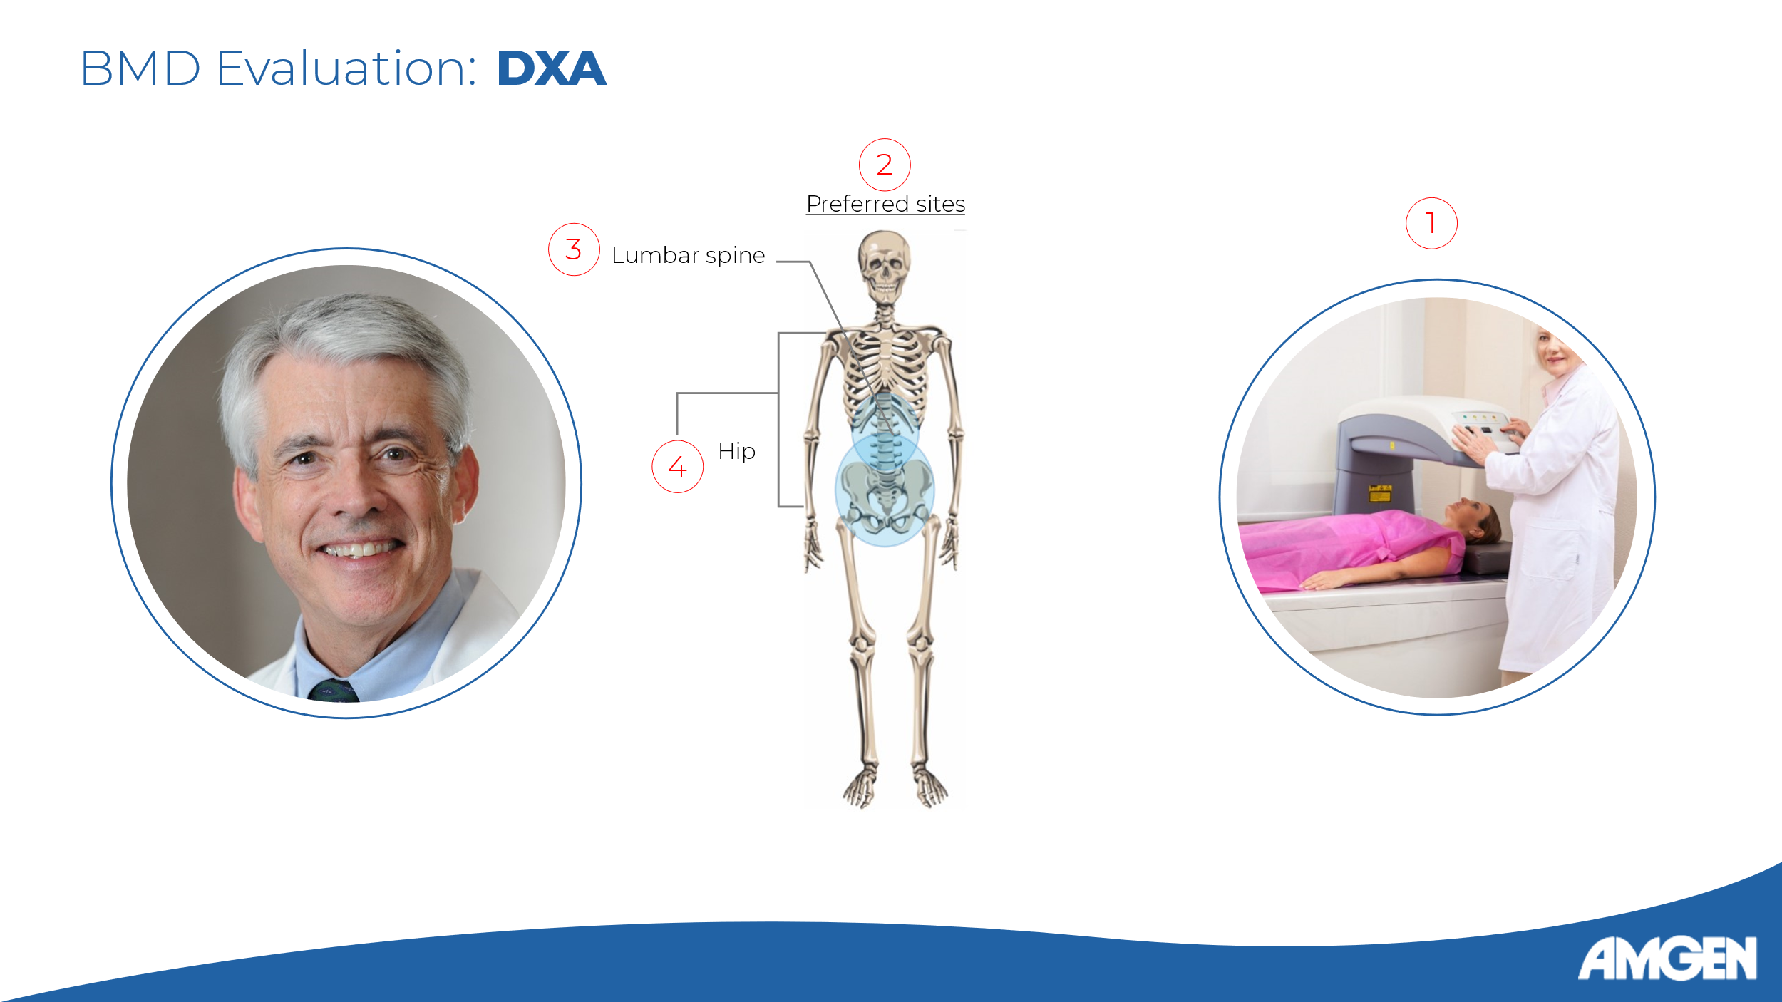
Slide 3:
[Dr. Watts] As we have seen last time, DXA is the preferred method to assess BMD in patients suspected of having osteoporosis. DXA images of two sites in particular - the lumbar spine and the hip - are obtained for diagnosis. [Camacho 2020: p3D]

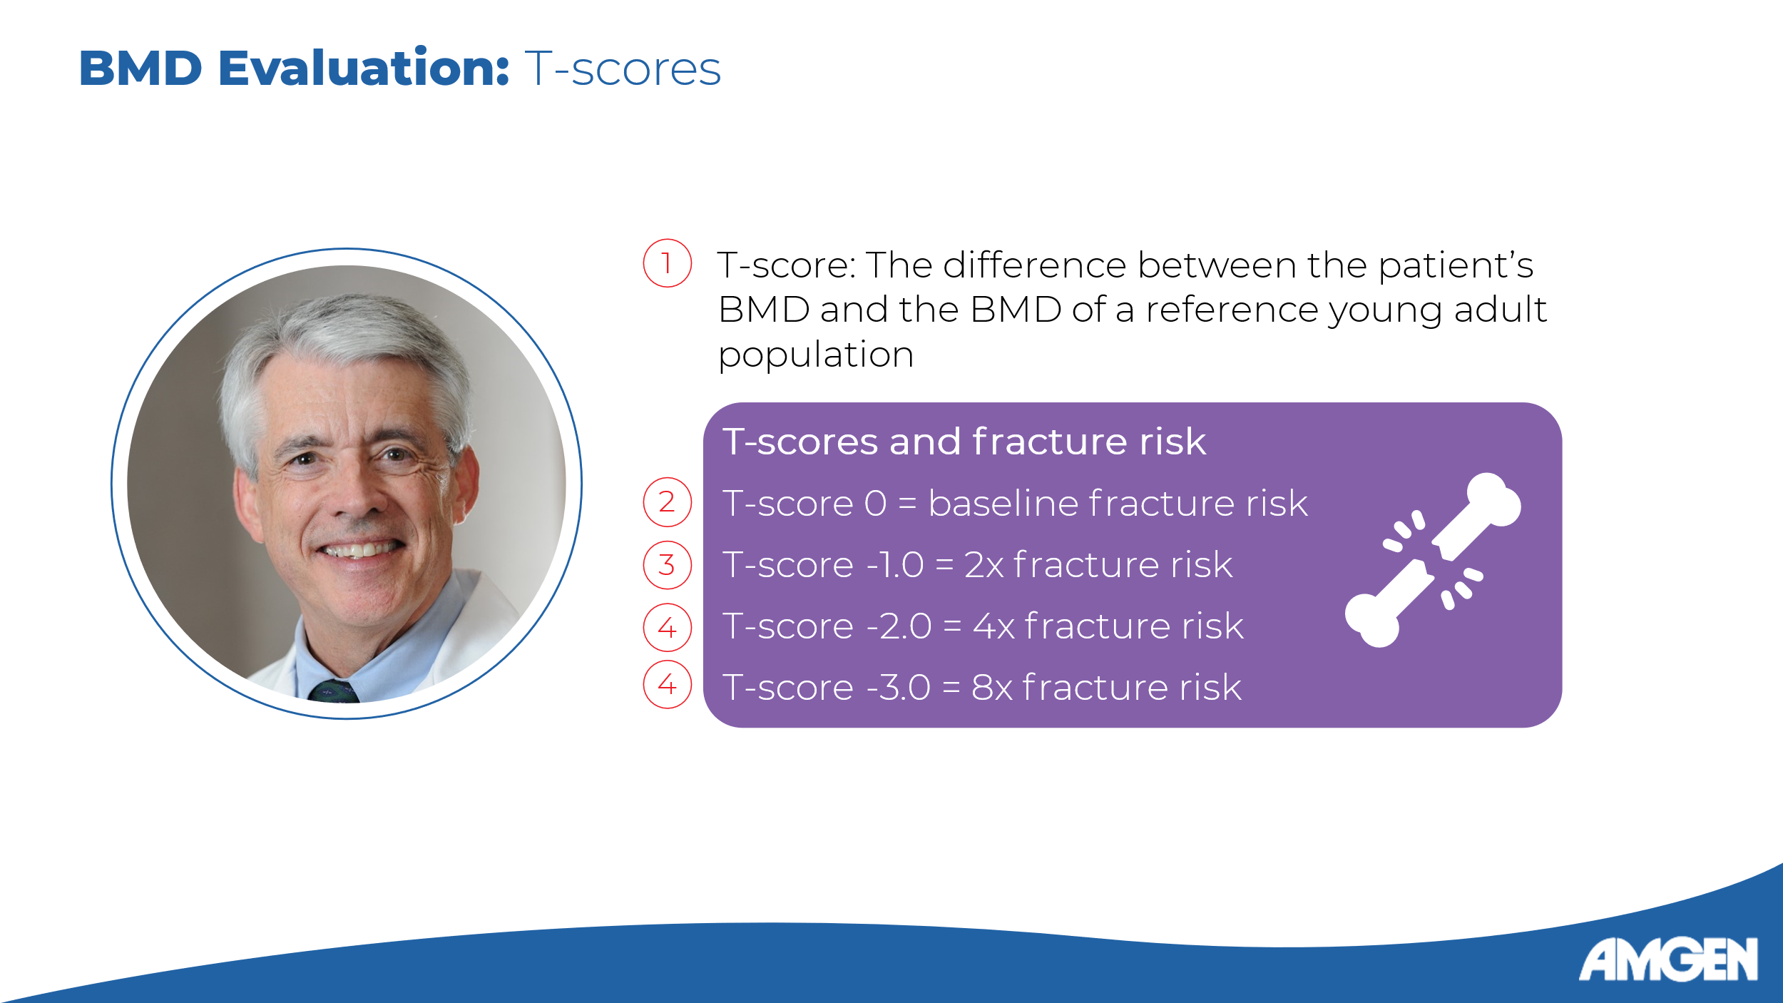
Slide 4:
[Dr. Watts] From these images, BMD is calculated and is then expressed as a T-score. A T-score quantifies the difference, in standard deviations, between the patient’s BMD and that of a reference population of young adults. [Saag: p52B; Leder: p152A] The risk of fracture increases approximately two-fold for each standard deviation of decrease in age-adjusted BMD, such that a T-score of -1.0 represents a two-fold increase, that of -2.0 a four-fold increase, and that of -3.0 an eight-fold increase in fracture risk. [Saag: p52B; Leder: p152A]

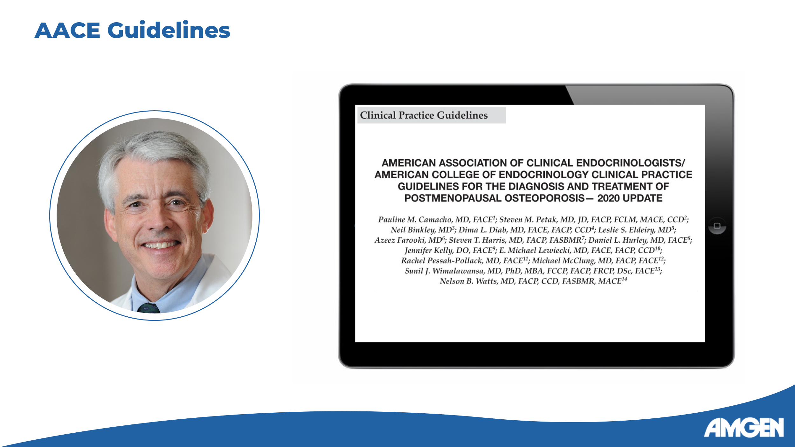
Slide 5:

[Dr. Watts] How is this information applied and a formal diagnosis of osteoporosis made? In 2020, the American Association of Clinical Endocrinologists, or AACE, published an update to their 2016 Guidelines for the Diagnosis and Treatment of Postmenopausal Osteoporosis. The updated guidelines list four conditions under which a formal diagnosis of osteoporosis is warranted.

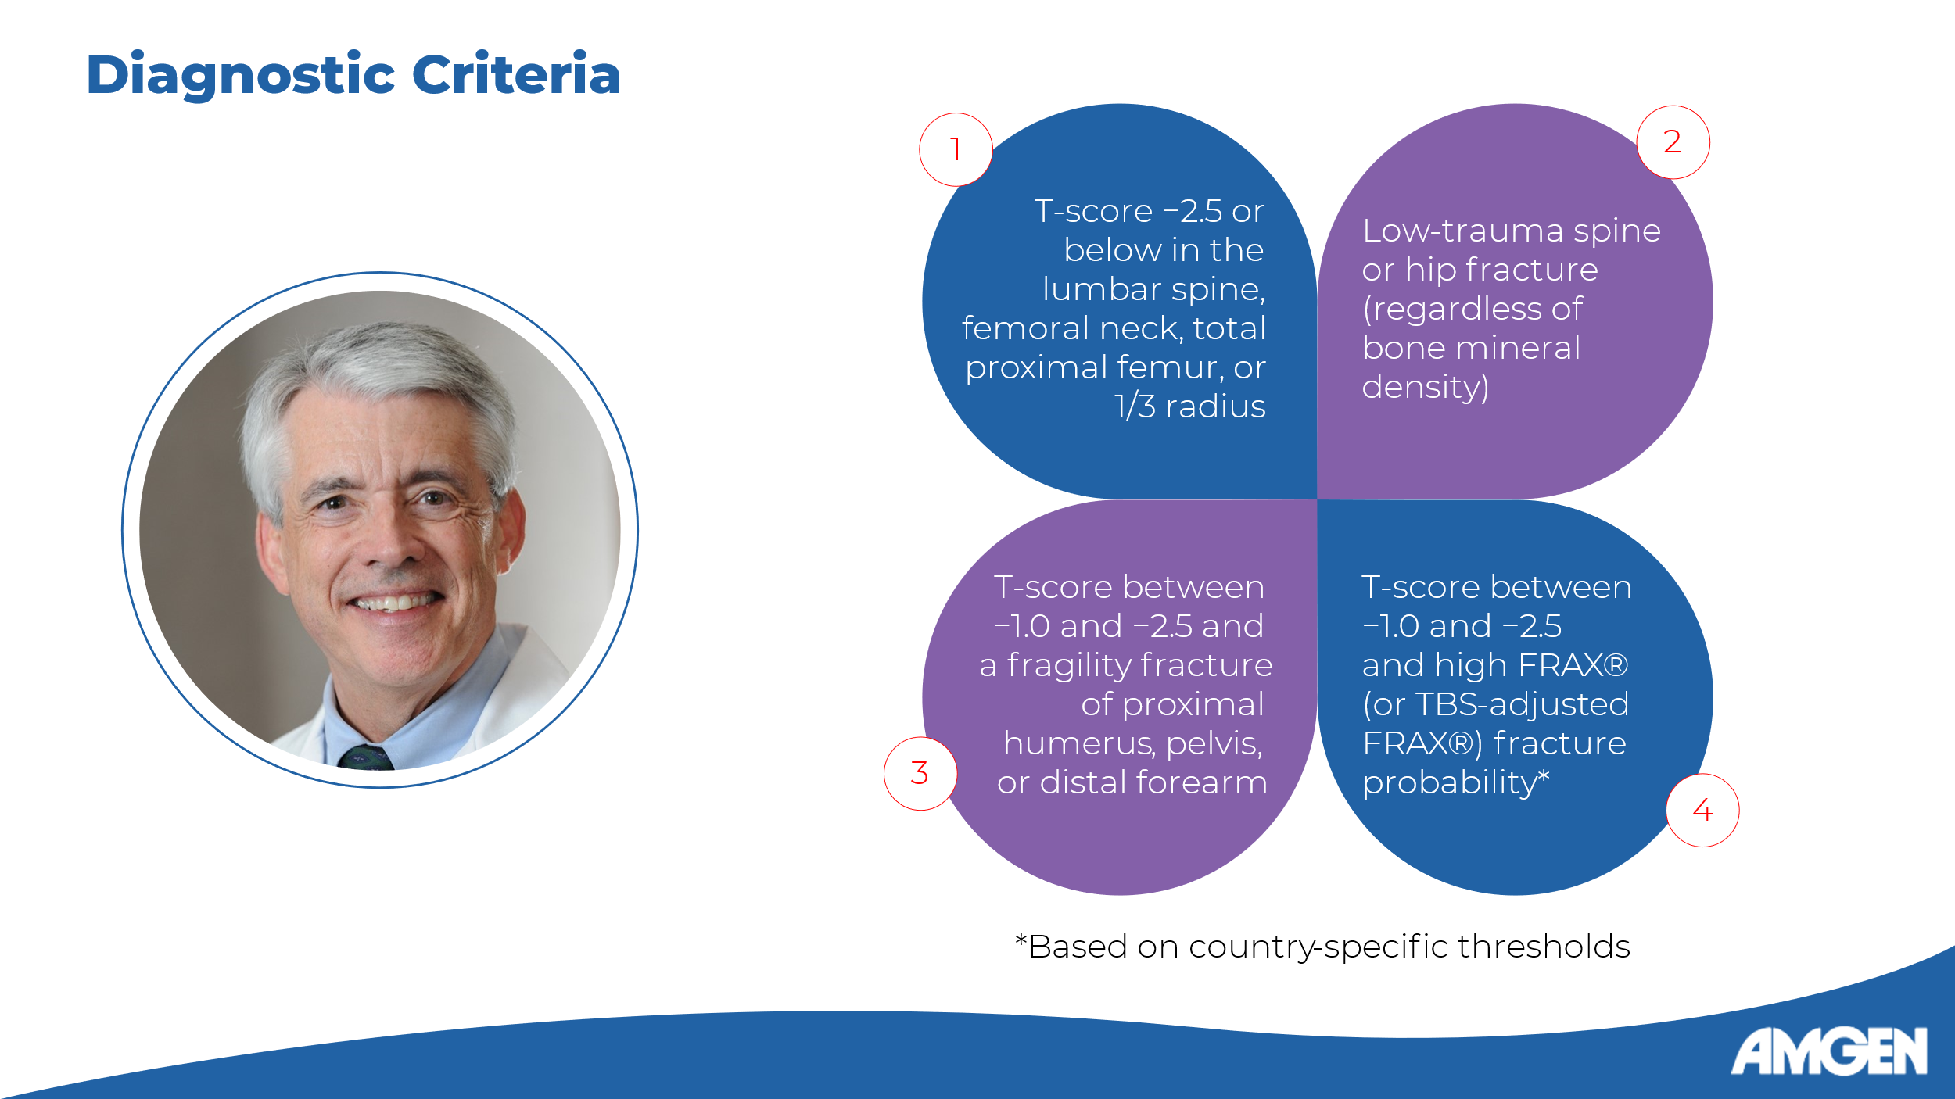
Slide 6:
[Dr. Watts] First, a T-score of -2.5 or below in the lumbar spine, femoral neck, total proximal femur, or one-third radius. Second, the occurrence of a low-trauma fracture in the spine or hip, regardless of BMD. Third, a T-score between -1.0 and -2.5 in addition to a fragility fracture in the proximal humerus, pelvis, or distal forearm. And fourth and final, a T-score between -1.0 and -2.5 in addition to high fracture probability as assessed by FRAX according to country-specific thresholds. Osteoporosis is diagnosed if any of these conditions is met. [Camacho 2020: p10A]

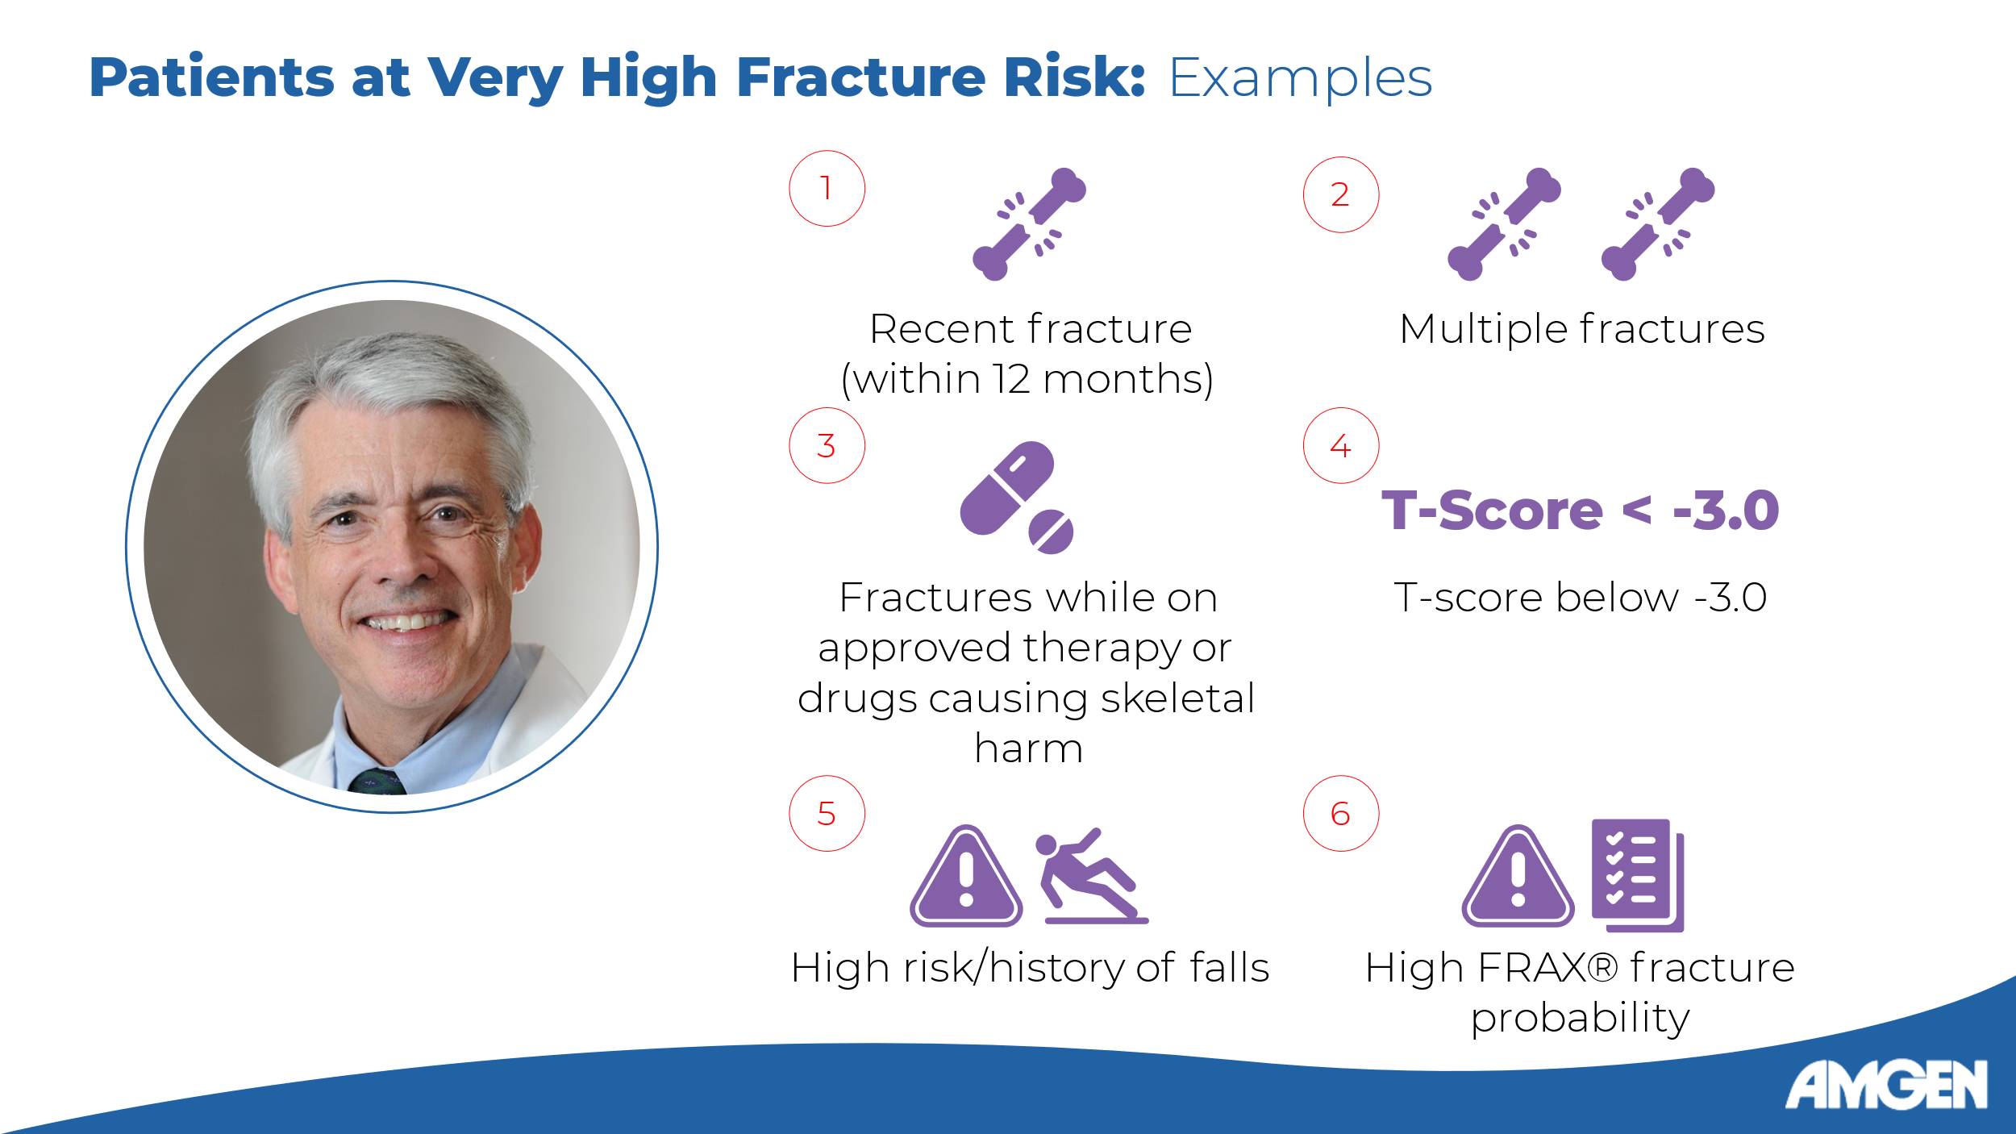
Slide 7:

[Dr. Watts] Once osteoporosis is diagnosed, further evaluation is warranted to inform treatment, disease management, and follow-up. Several factors may point to a particularly high risk of fracture. Examples include the occurrence of recent fractures in the last 12 months, multiple fractures, fractures during approved therapy for osteoporosis or while on high risk medications such as glucocorticoids, very low T-scores, increased fall risk or a history of falls, and high FRAX-calculated fracture probability. [Camacho 2020: p36A]

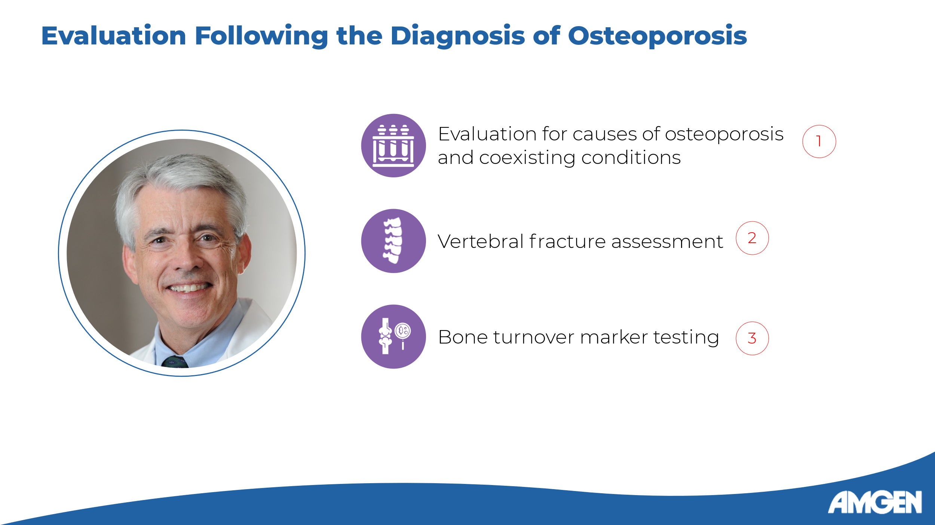
Slide 8:

[Dr. Watts] Beyond stratification, disease assessment following diagnosis should also include an evaluation for causes, as bone loss may be caused or exacerbated by coexisting conditions which may be asymptomatic and require laboratory testing. [Camacho 2020: p6D, p14A] Appropriate post-diagnostic evaluation also includes assessing for vertebral fractures, which indicate a higher risk for future fractures. [Camacho 2020: p6E, p14B] In the next video, we will discuss imaging techniques used to look for the presence of vertebral fractures. Finally, the post-diagnostic assessment may include the quantification of bone turnover markers, including both osteoblast-derived factors and metabolic by-products of bone resorption, which can predict higher rates of bone loss. [Camacho 2020: p6F, p16A-B]


Slide 9:

[Dr. Watts] That concludes our brief overview of how osteoporosis is diagnosed. Next time, we conclude the series with a deeper dive into how DXA scans are acquired, and how to interpret DXA radiographs.

