

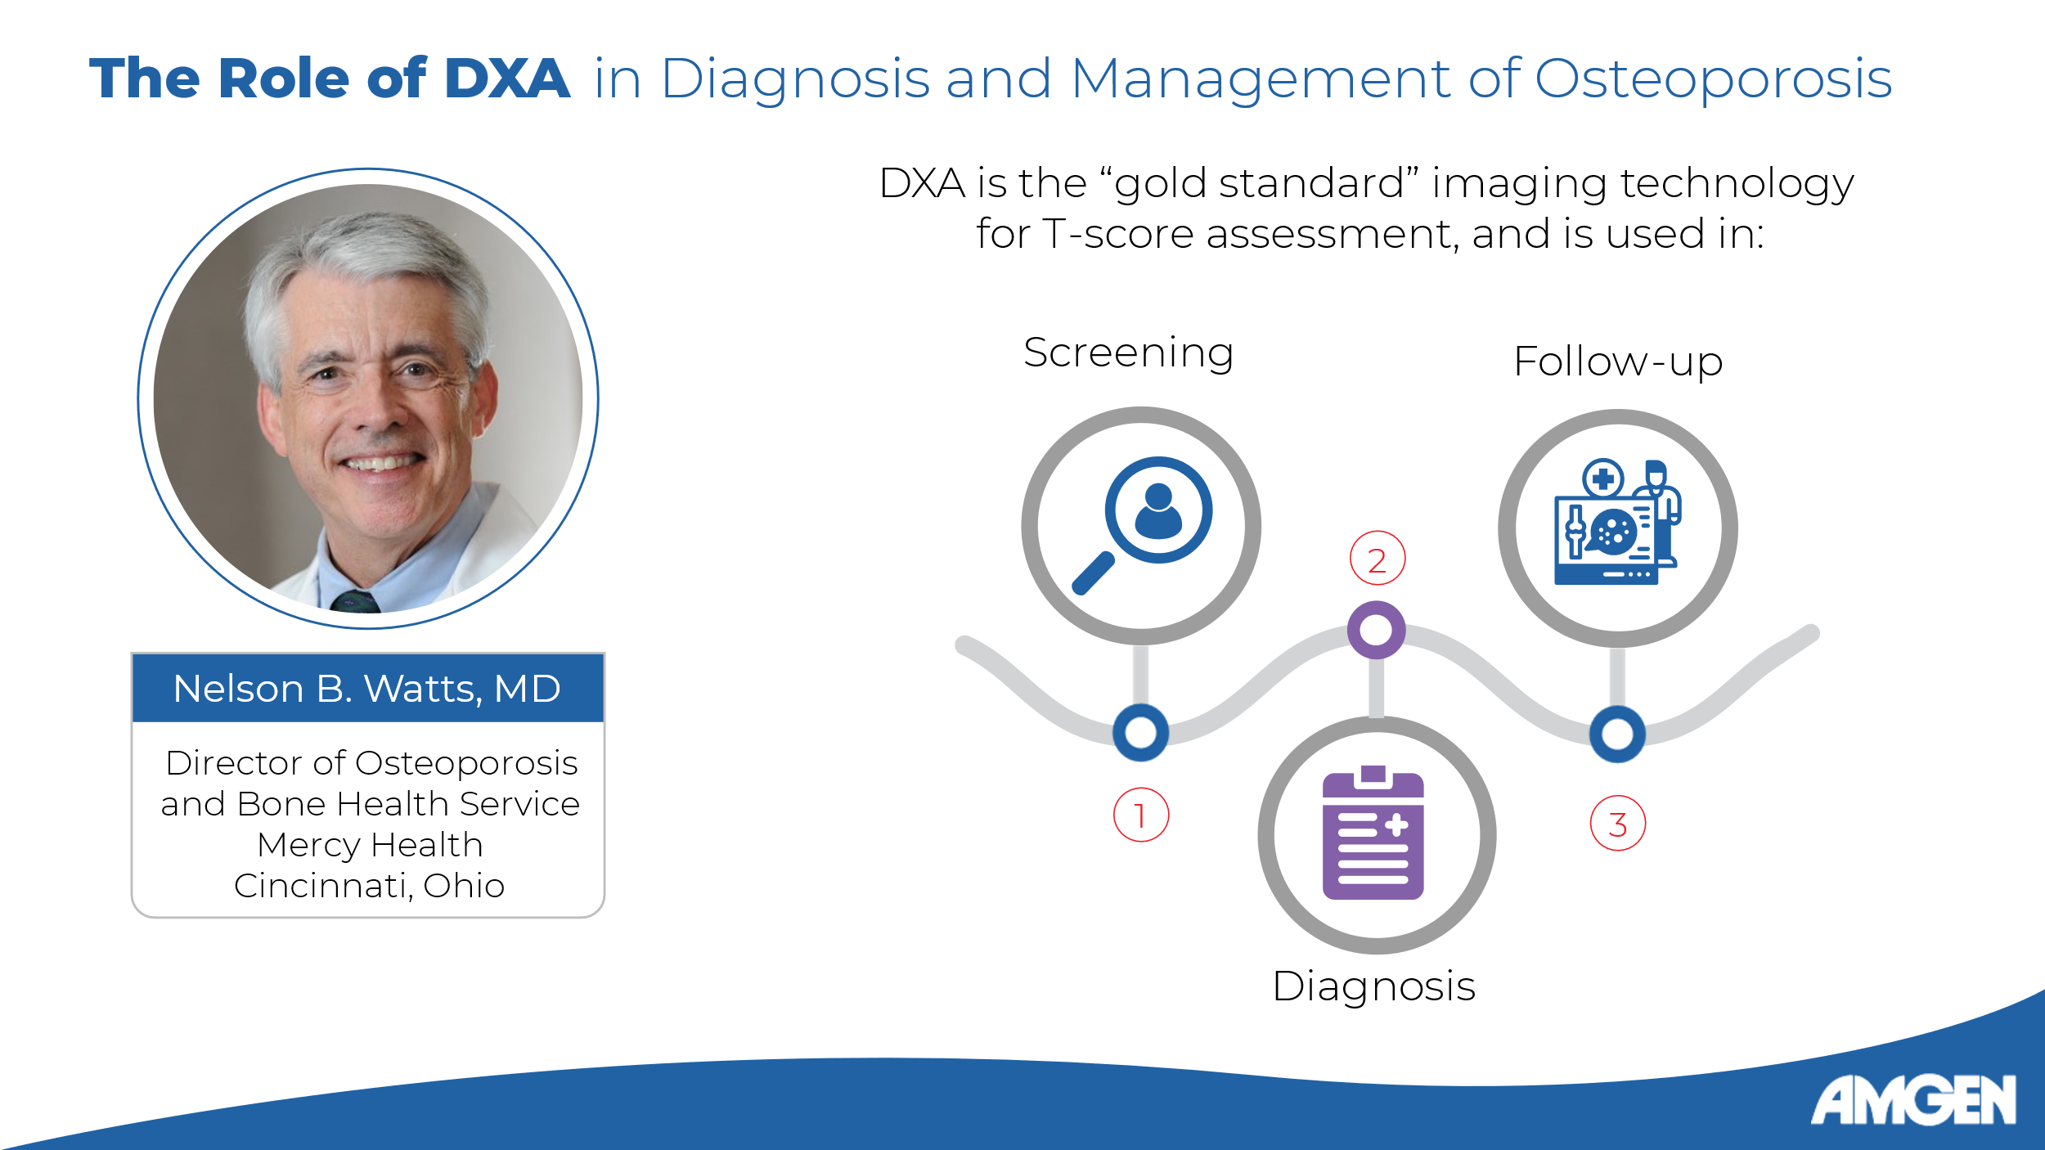
Slide 2:
[Dr. Watts] Hello, and welcome to the fourth and final video in the Osteoporosis Clinical Insight series. I am Dr. Nelson Watts, and I will be your guide as we take a deeper dive into the topic of DXA. We will discuss common pitfalls in DXA acquisition, the best practices to minimize such errors, and what constitutes a good DXA report. Finally, we will look at the use of DXA to look for vertebral fractures.
[Dr. Watts] We saw in earlier videos that DXA is the “gold standard” for assessing BMD and fracture risk. [Leder 2020: p161A] As such, it is a useful tool employed throughout the patient journey: to screen for low BMD, to formally diagnose osteoporosis, and to follow up the BMD response to treatment. [Camacho 2020: p3D, p7A; Saag: p61B] While extremely versatile, it is important to remember that we cannot rely only on DXA-derived T-scores to diagnose osteoporosis and choose patients for treatment - as we have seen in previous videos, FRAX and complementary TBS data can help identify patients with T-score better than -2.5 that would still greatly benefit from treatment. [Camacho 2020: p6C]

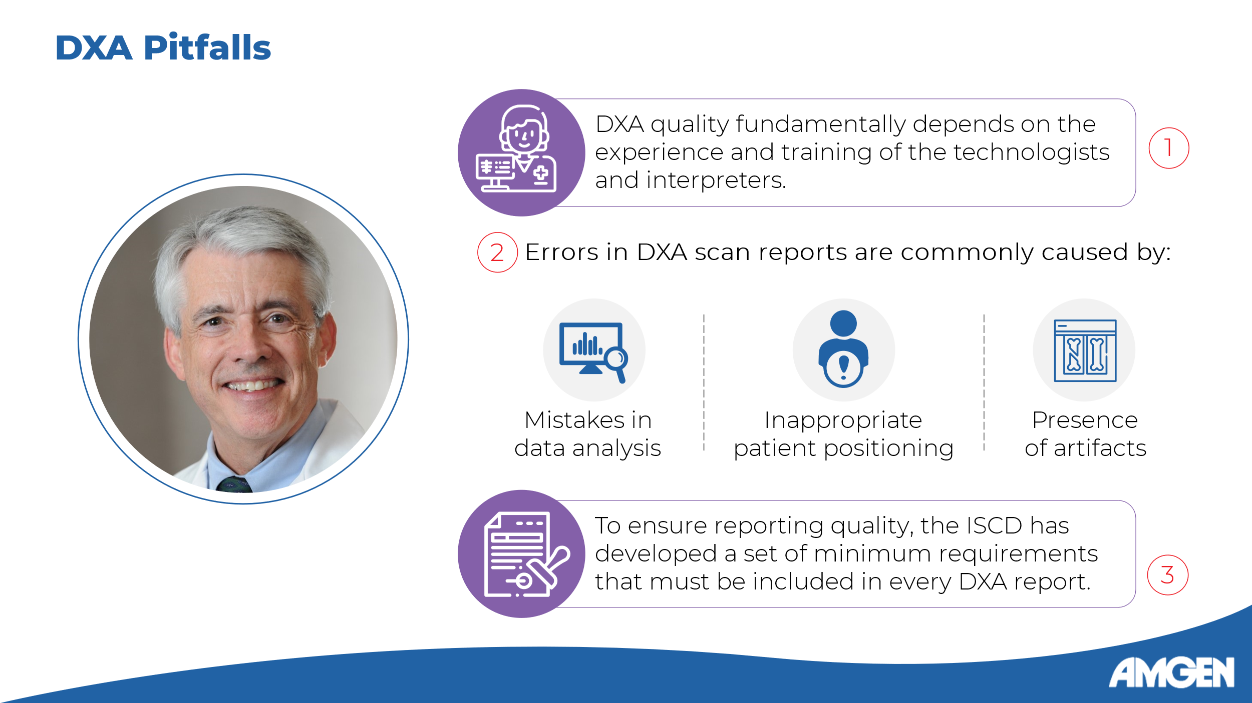
Slide 3:
[Dr. Watts] Let’s look now at some of the errors that can happen during DXA image acquisition and interpretation. It is important to stress that the quality of a DXA scan ultimately depends on the skill and experience of the technologists who acquire the images and the interpreters that analyze them. [Saag: p60F]
And mistakes are surprisingly common - one study in Italy found that up to 90% of DXA scans and reports contained at least one mistake. [Saag: p60C] The most common errors included data analysis mistakes, inappropriate patient positioning, and radiographic artifacts. [Saag: p60C]
To minimize such errors, best practices have been developed. For example, the ISCD has established a set of minimum requirements which must be present on every DXA report. [Saag: p60D-F]

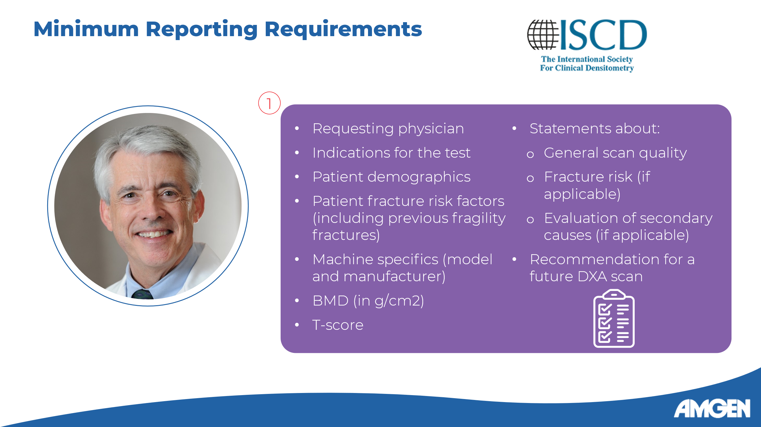
Slide 4:
[Dr. Watts] These minimum reporting requirements include general information about the requesting physician and the indication, patient details, including demographics and fracture risk factors, machine specifics, numerical BMD and T-score values, statements about the general quality of the scan, and a recommendation concerning another DXA scan in the future. Where appropriate, the report can also contain a statement on fracture risk or the need to evaluate for secondary causes of osteoporosis. [Saag: p61A]

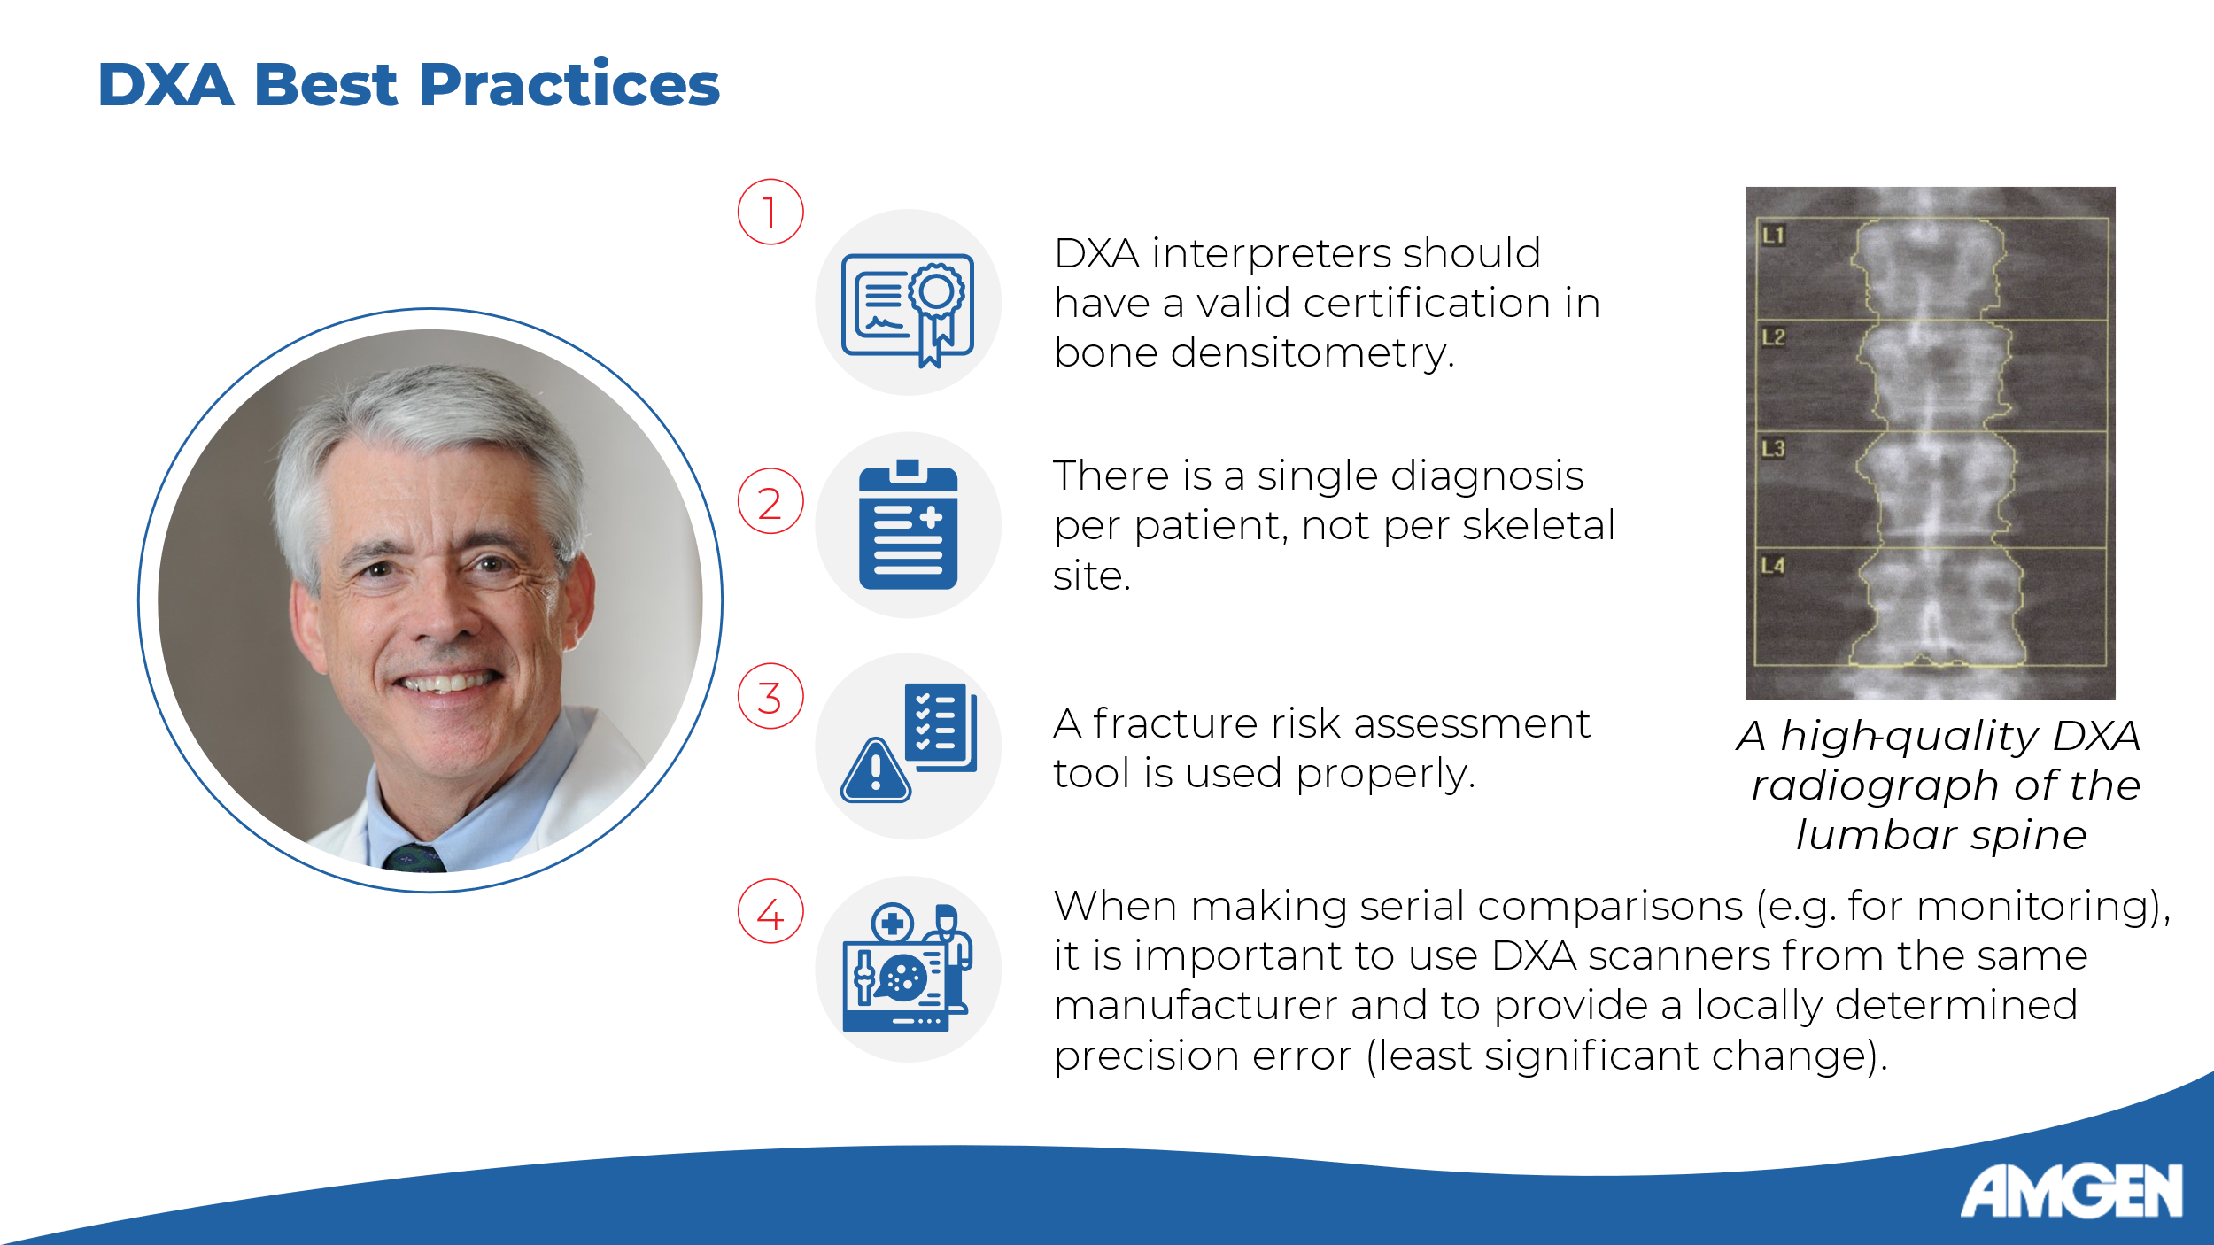
Slide 5:

[Dr. Watts] In addition to following reporting recommendations, there are several other best practices to follow. The DXA interpreters must possess a valid certification in bone densitometry, there should be only one diagnosis for each patient rather than a diagnosis for each site imaged, and, if applicable, a fracture risk assessment tool such as FRAX is appropriately used. [Saag 2019: p60F]
Lastly, we should mention that

serial DXA scans may be performed to correct for artifacts or to monitor BMD changes over time. In such cases, it is crucial that serial measurements be performed on the same system, as only when a system’s local precision error is known can the significance of the BMD change be calculated, using the ISCD-developed formula for least significant change. [Shepherd 2007: p1-B, p2A-B]
When these best practices are implemented and pitfalls avoided, a high-quality DXA scan like the one shown on the right can maximally inform the patient’s primary healthcare providers.

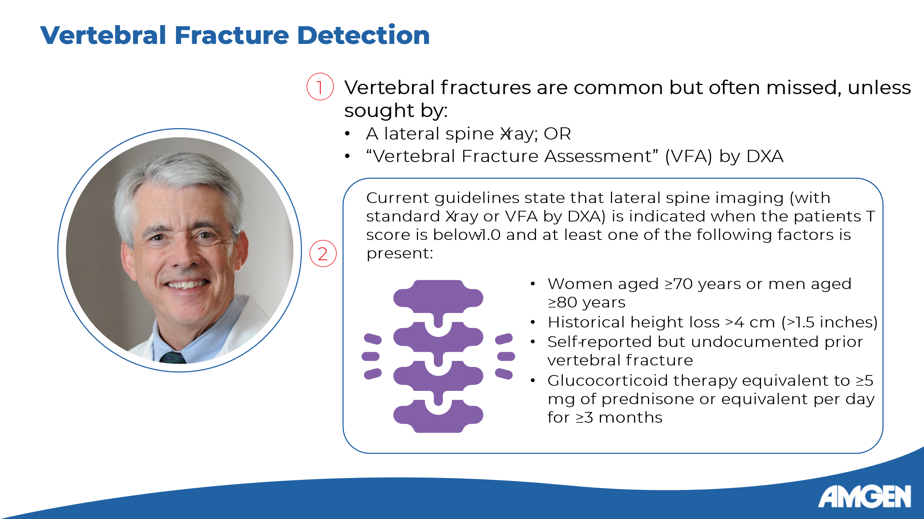
Slide 6:
[Dr. Watts] Finally, let’s examine the role of DXA in vertebral fracture assessment. As you will recall, checking for prevalent vertebral fractures is part of the post-diagnosis disease evaluation, [Camacho: p6E] as they are an independent predictive factor of future fractures. [Malgo: p1A]
However, vertebral fractures are often missed if not sought out specifically, and the two most useful methods for this include a regular lateral X-ray of the spine, as well as vertebral fracture assessment - of VFA - which is done by DXA. [Camacho: p14B]
How do we assess which patients need a VFA? The current AACE guidelines recommend that a VFA be done in patients with a T-score below -1.0 who fall in one of the following four categories: 1) being 70 and above or 80 and above for women and men, respectively; 2) having lost more than 4 centimeters in height; 3) being aware of a prior vertebral fracture that is not otherwise documented; and 4) receiving glucocorticoid therapy equivalent to 5 mg or more of prednisone for 3 months or longer. [Camacho: p14C]

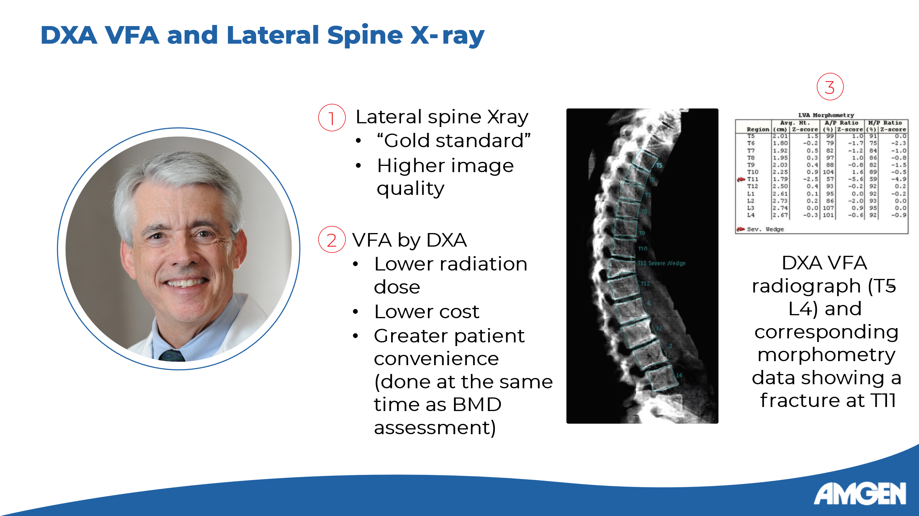
Slide 7:

[Dr. Watts] How do the two methods for vertebral fracture detection compare? The lateral spine X-ray is considered the gold standard as it provides high image quality. [Oh: p1C; Malgo: p2B] However, VFA has many advantages, including a much lower radiation dose, lower cost, and the convenience of assessing for vertebral fractures at the same time as measuring BMD. [Oh: p1D, p2A] The image on the right shows a DXA radiograph that was used in VFA to identify a fracture in the T11 vertebra. [Kennel 2020: p18A] The emerging consensus is that VFA is just as specific and sensitive in detecting vertebral fractures as a lateral X-ray. [Oh: p2B]


Slide 8:

[Dr. Watts] That concludes our discussion of some of the most important principles of DXA scan acquisition and reporting, and the Osteoporosis Clinical Insights series as a whole. I hope you have enjoyed the series!

